|  |  |  |
| --- | --- | --- |
|  | AptechIDCE160511H |  |

**Yash Gems Jewelry**

**DOCUMENTATION**

**Group’s members:**

**- Student18080063 : TRAN NGHE NANG**

**- Student1148047 : PHAM THAI SON**

**Instructor: HUỲNH KHÁC DUY**

**Class: ACCP1808**

**CERTIFICATION**

* Thank to the instruction of Instructor **HUỲNH KHÁCDUY**, all members of the group have made the efforts to complete the requirement of eProject.
* Thank to **AptechSaigon** for supporting us during the learning process.
* Thank to **Aptech Computer** **Education** for giving us the opportunity to improve experience in many aspects.

**By the approvement of Mr. HUỲNH** , we are proud to present this product with the appreciate for him.

We expect this product can get the archievements the eProject requires.

Thank you.

**CATEGORY**

**Content 94 pages**

Section 1: Introduction 04

Section 2: Acknowledgements 10

Section 3: Synopsis 10

Section 4: Analysis 11

Session 5: Design 12

Session 6: User guild 20

Session 7: Developer guild 52

***Section 1: Introduce the Project***

## The background:

Mr. Robert D’costa started the business from the scratch in 2005. The flagship company of Yash Gems & Jewelleries (P) ltd was formed to carry on the business of manufacturing and trading of Gold & Diamond Jewellery.

To manufacture diamond Jewellery with ultimate brilliance, Yash has employed the latest and most advanced technologies for manufacturing diamond jewellery.

As a supplier to some of the most exclusive retailers, Yash have intimate knowledge of the cultures and trends of the markets served. The national sales and distribution network team allows them to cultivate a close relationship with the customers and guarantees efficient services.

Yash believes in reflecting their jewellery with special magic, conjured by melting of spirit and dedication, labour and craftsmanship, and art of work. The talented designers, skilled craftsmen and dedicated managers use state-of-the-art technology to produce the finest level of diamond jewellery for leading retailers.

The company’s sincere desire is to give every client a reason to feel good. And policy is to offer top quality merchandise to the customers at the best possible price.

With a vision and motto of providing its customers products of impeccable quality, Yash has outnumbered many in innovative design and quality, making itself the benchmark and hallmark of the Indian jewellery industry.

## Main task:

### Introduce the task:

**To develop a complete web-based solution for Yash**

* The motive of this Online Jewellery Shopping Web Application is to allow the user to play with the search tool and create different combinatorial search criterion to perform exhaustive search.
* Provide Interactive interface through which a user can interact with different areas of application easily.
* A search engine that provides an easy and convenient way to search for products specific to their needs. The search engine would list a set of products based on the search term and the user can further filter the list based on various parameters.
* Provide Shopping Cart feature thereby allowing the user to add products to or remove products from the shopping cart by dragging the products in to or out of the shopping cart.
* Provides accurate level of security so that transactions can be made confidentially.

People who are not much aware of the system can easily make purchase by easy to register interface.

***Section 2 : Acknowledgements***

C# MVC Framework and others libraries … HTML5, CSS, Javascript and Bootstrap …

***Section 3 : Synopsis***

1. User Side :
   * Home page : displays the latest products and products on sale.
   * Product page : displays all products, categories, brands and stones
   * Search page : displays the products have same keyword.
   * Register page : for user register account.
   * Cart page : show product(s) have add to shopping cart.
   * Payment page : create the order.
   * Product detail page : display the detail of product.
   * Login Page : allow user login his/her own account.
   * Profile Page : show the user information and order histories.
2. Admin Side :
   * Login page : only for admin to login to admin side pages.
   * Dashboard page : show some data the admin need.
   * Items page : displays all products of site, insert, update, delete.
   * Brands page : displays all brands of site, insert, update, delete.
   * Categories page : displays all categories of site, insert, update, delete.
   * Certificates page : displays all certificates of site, insert, update, delete.
   * Discount page : allow admin add discount to product. Insert, update, delete.
   * Inquiries page : receives inquiries from user.
   * Orders page : show all orders.
   * Users page : show all user who have register account.

***Section 4 : Analysis***

1. User case

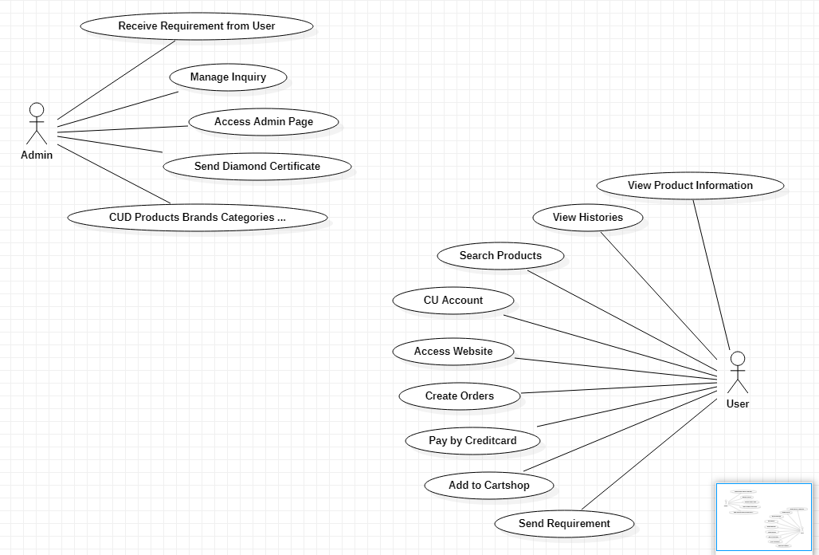

1. Database Diagram

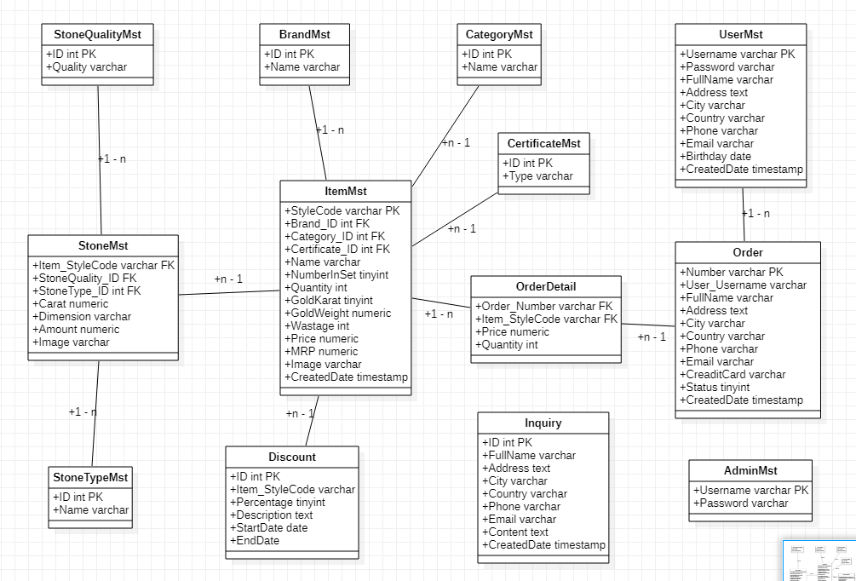

***Section 5 : Design***

1. User Site Diagram :
   * Template

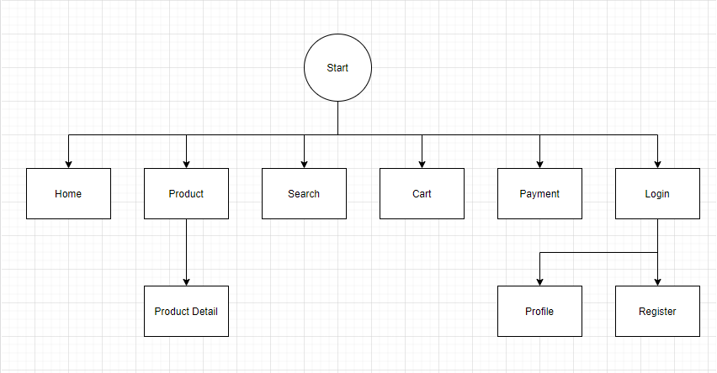

* Home

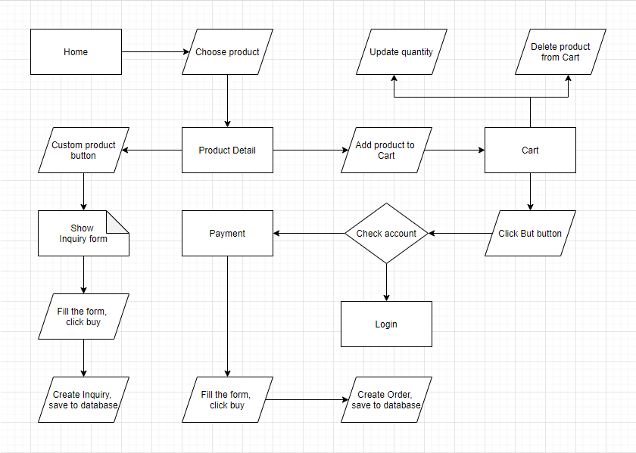

* Product

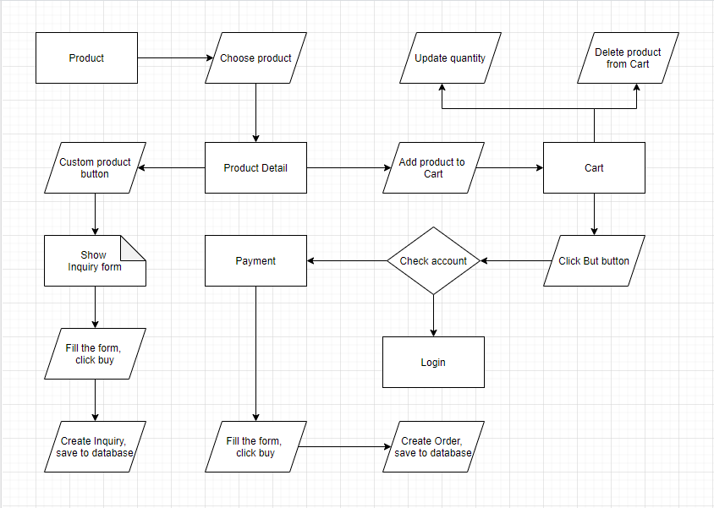

* Search

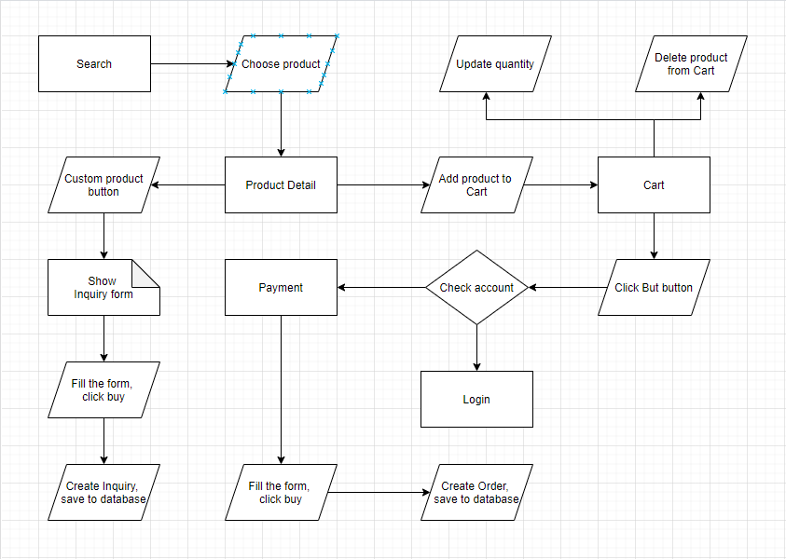

* Login

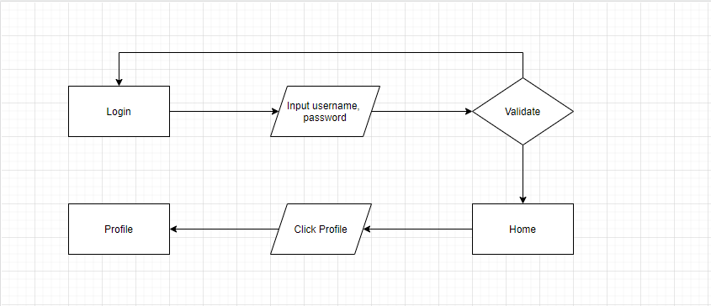

* Register

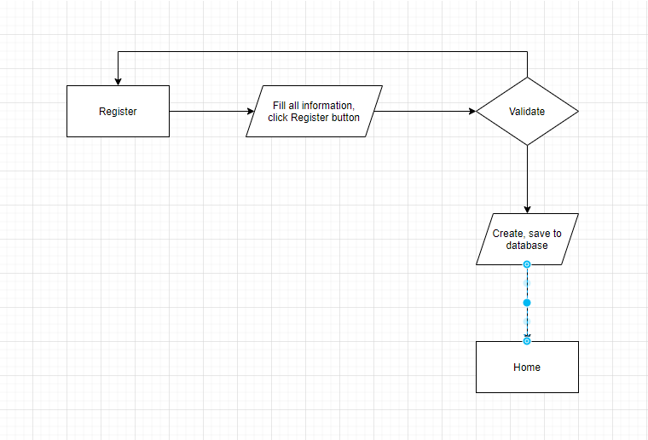

* Profile

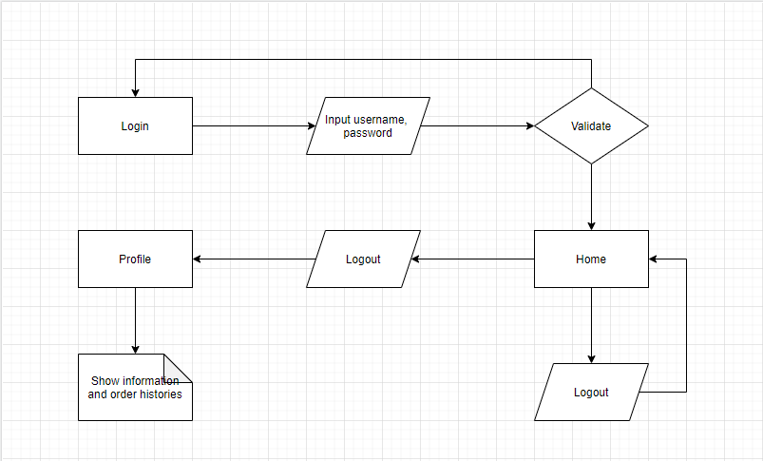

1. Database :

* Diagram

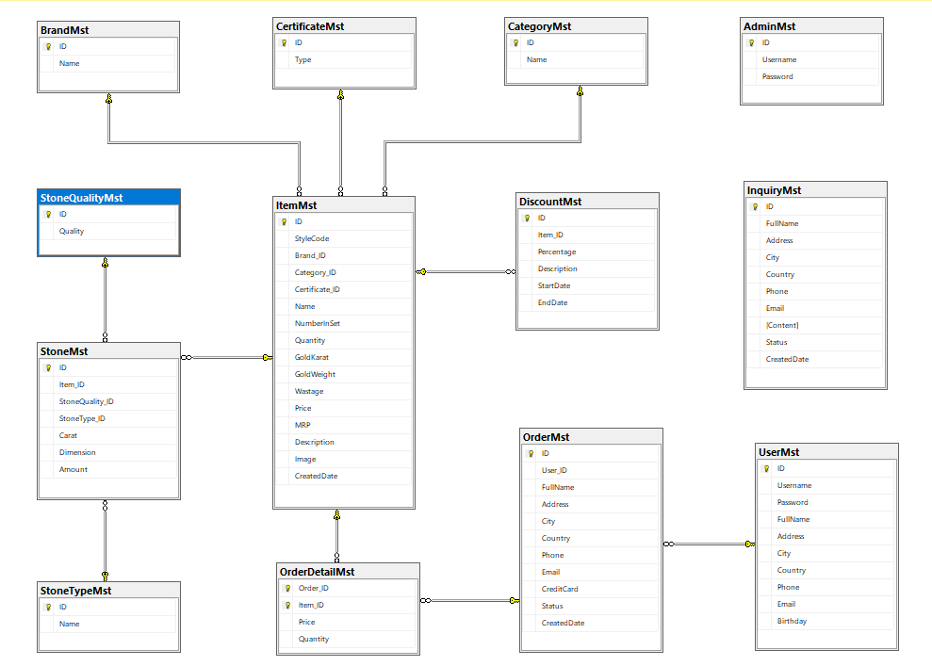

* Admin Table

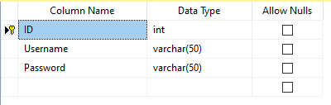

* Brand Table

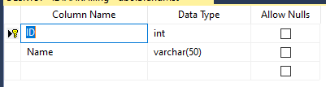

* Category Table

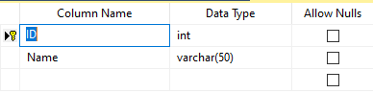

* Certificate Table

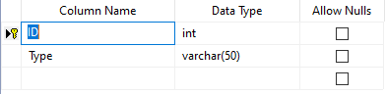

* Discount Table

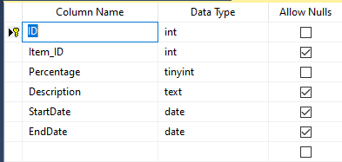

* Inquiry Table

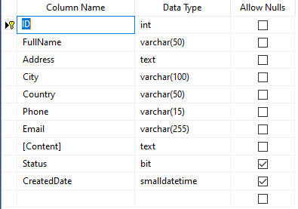

* Item Table

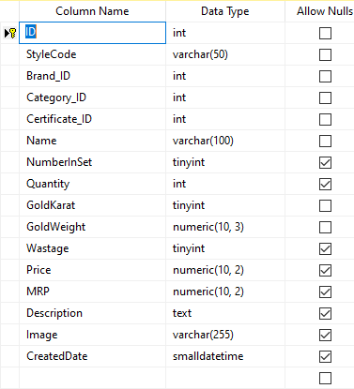

* Order Table

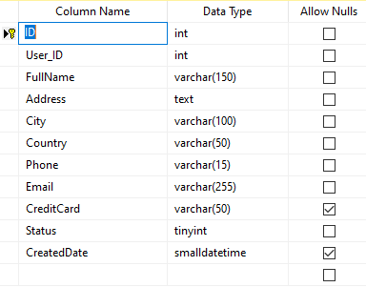

* Order Detail Table

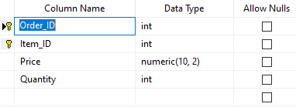

* Stone Table

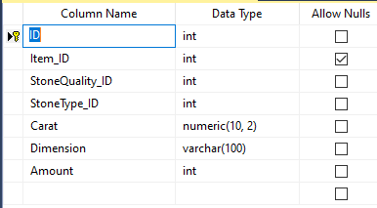

* Stone Quality Table

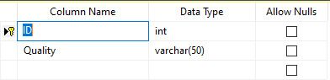

* Stone Type Table

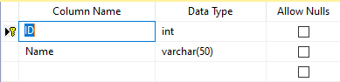

* User Table

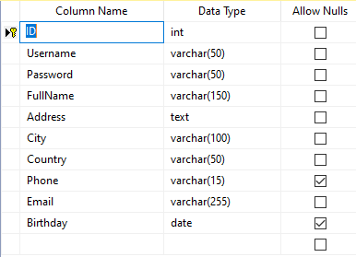

***Section 6 : User Guild***

1. User Side :
   * Header : contains Logo, Search bar, Login button and Cart button, Menu.



Logo : website Logo, click to back to Home page.

Search bar : Input some keywords to finds toe product(s) contain that keyword, and will show on Search page.

Login button : for user sign in their account, to make an order, view the histories etc.

Cart button : go to the Cart page for show all the product(s) have added to cart.

Menu : contains Home page and Product page.

* Footer : contains Logo, some Contact information, Menu, Services



Logo : website Logo, click to back to Home page.

Contact Information : contains company Address, Email and Hotline number.

Menu : contains Home page and Product page.

Services : contains Cart page and Login page.

* Home : contains Main image, Latest products and Products on sale.

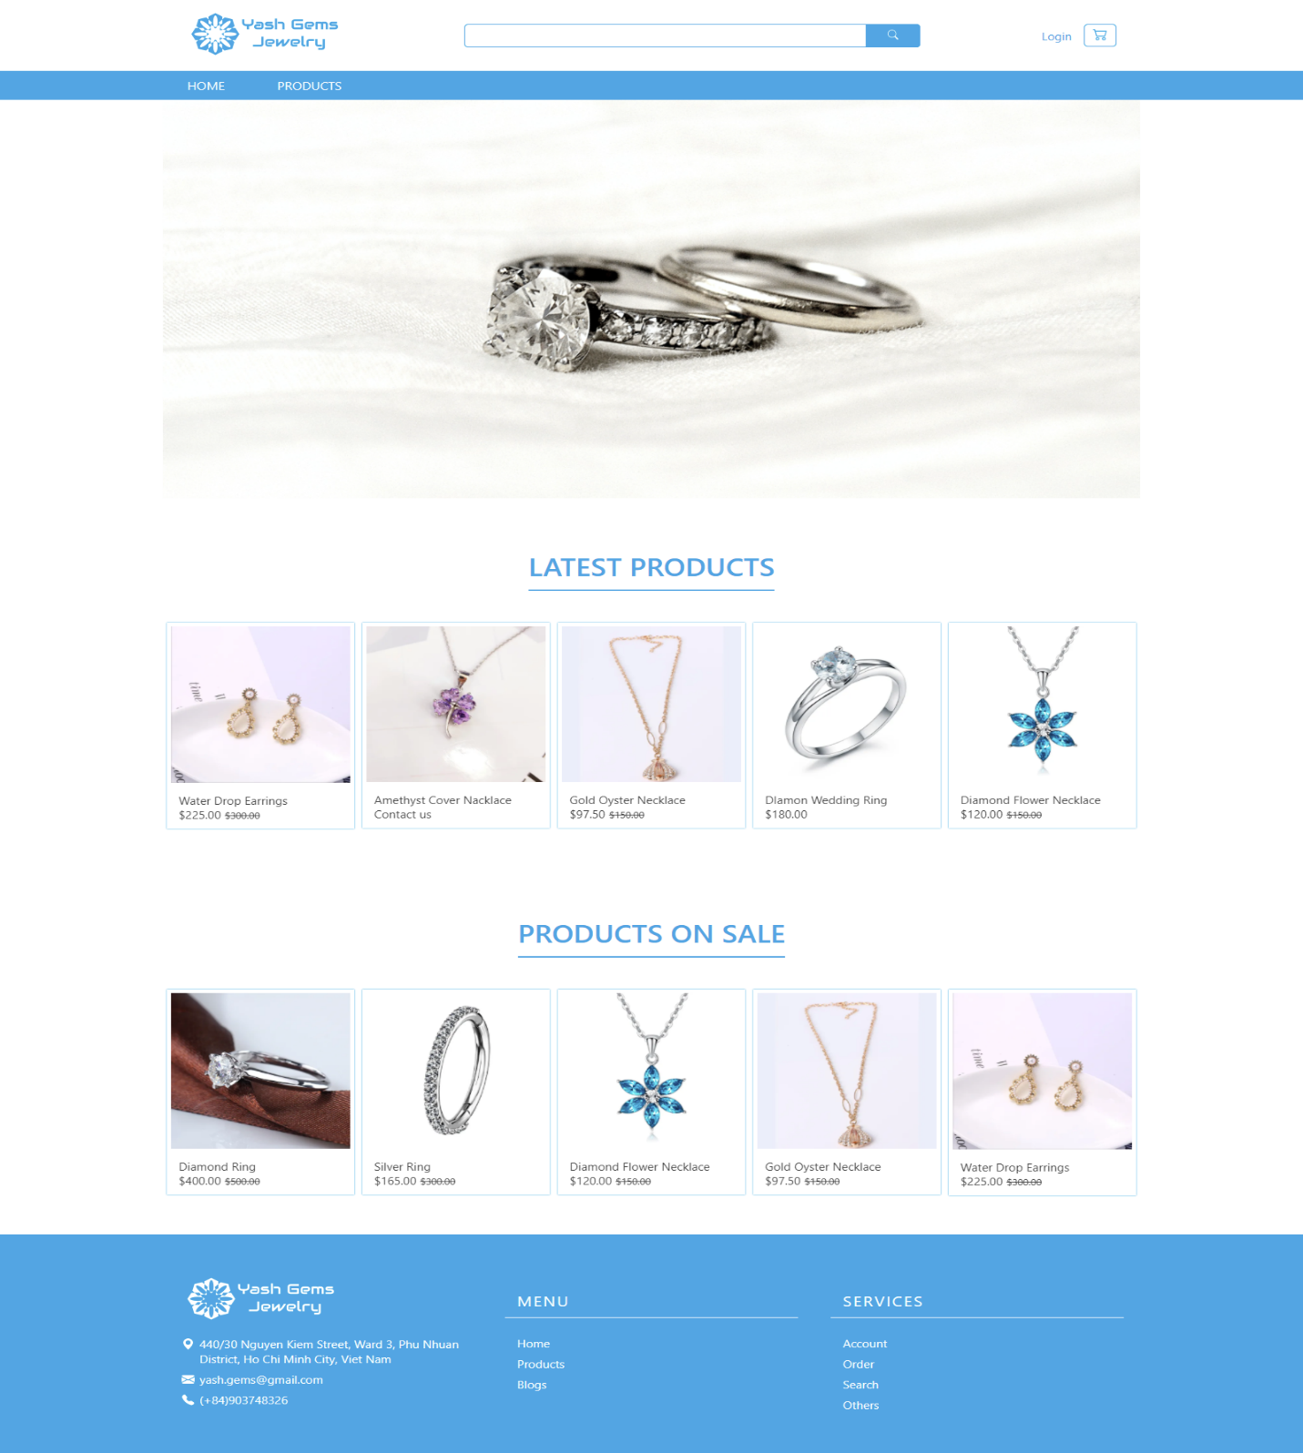

Main image : click it will move to Product page.

Latest products : display the latest product(s) of company, can move left and right view more products, choose the product move to Product detail page.

Products on sale : display the product(s) on sale by current date of company, can move left and right view more products, choose the product move to Product detail page.

* Product : display all the product of company.

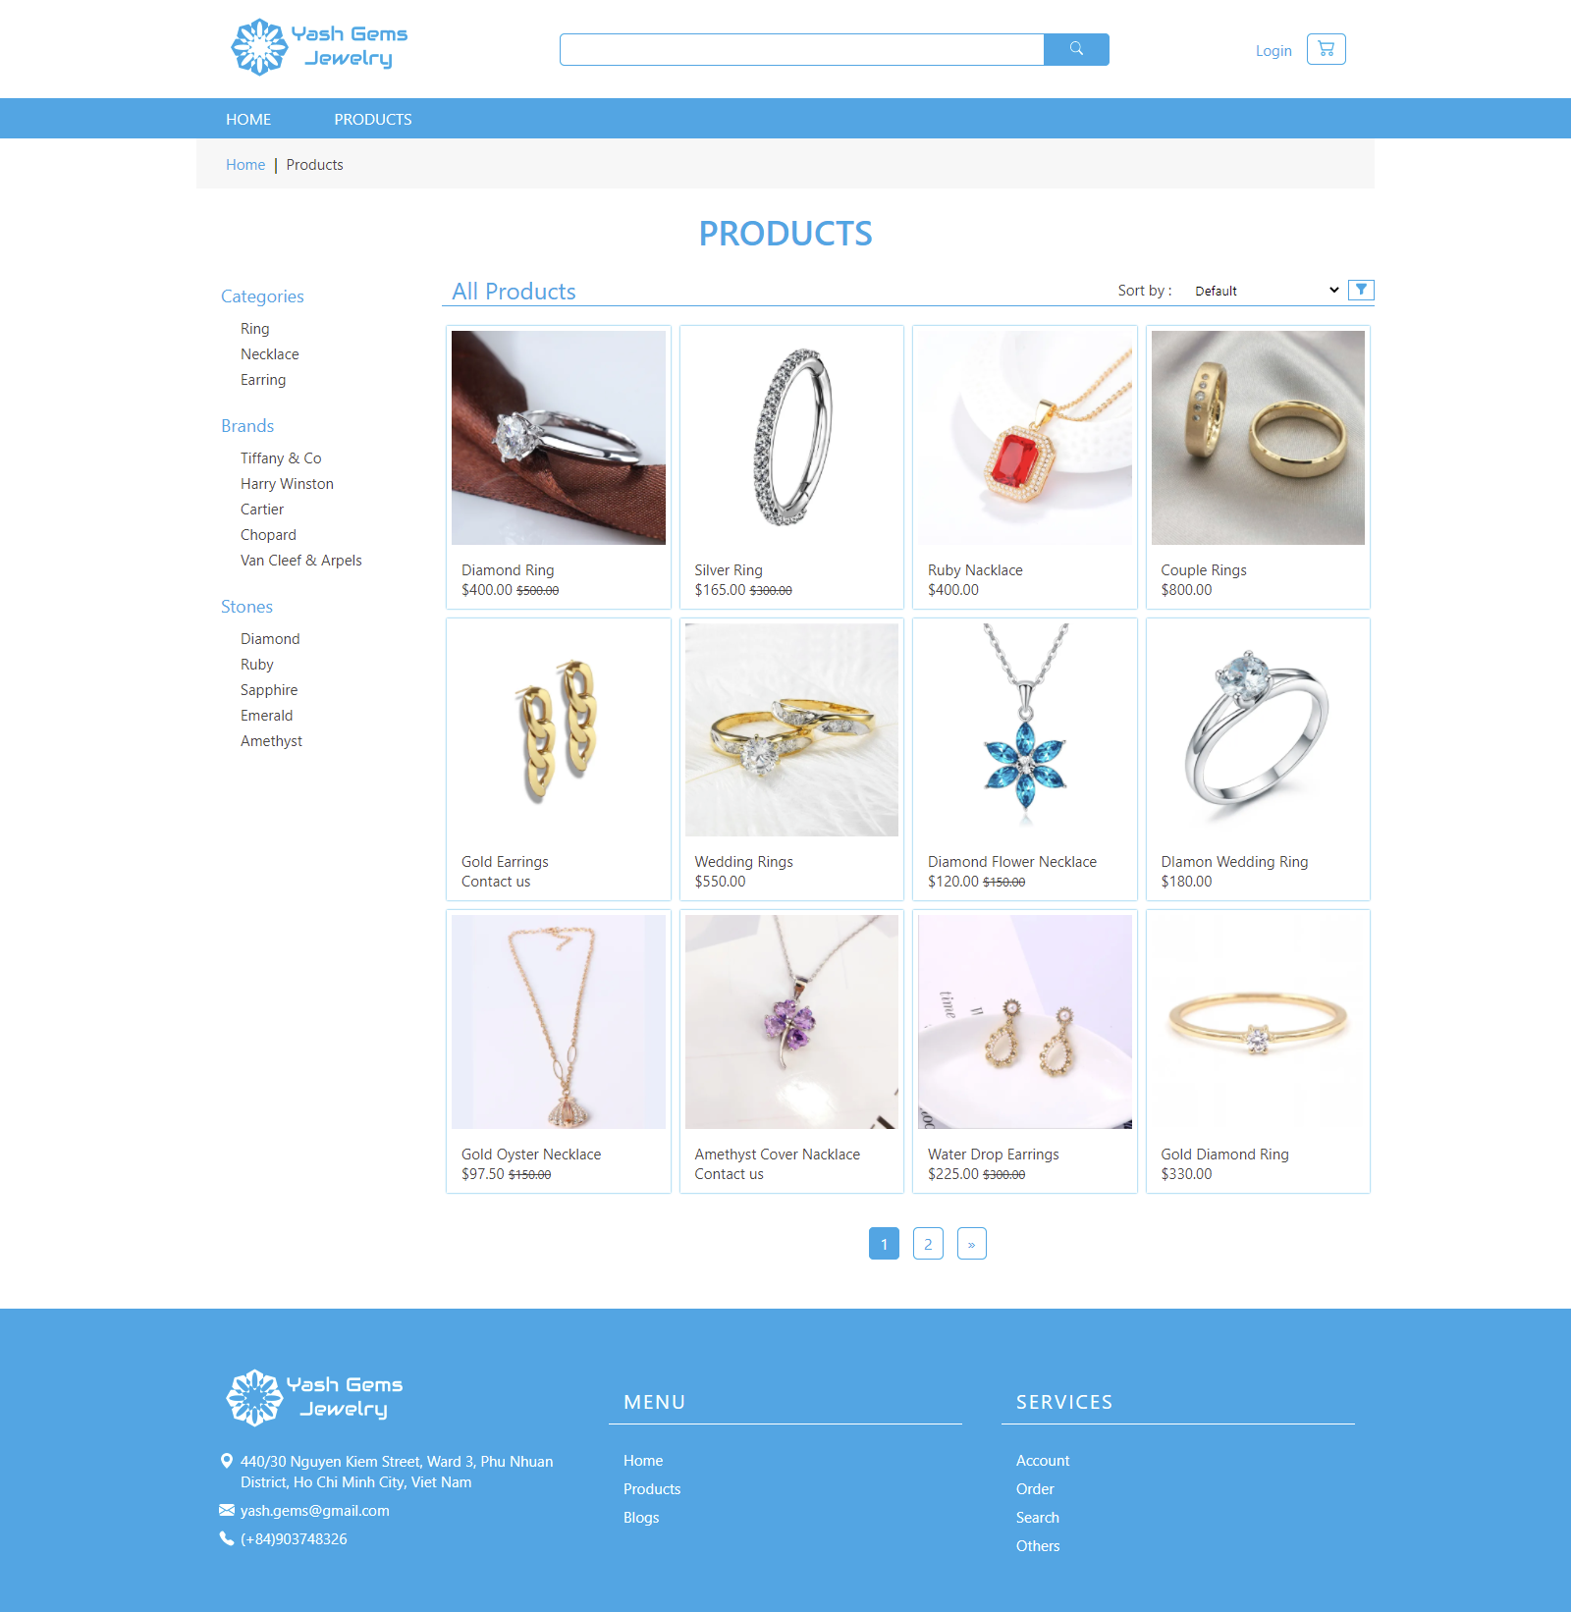

Filter box : allows user find the product(s) easily, there are contain 3 kind for filter :

1. Categories : Filter by product category.
2. Brands : Filter by product brand.
3. Stones : Filter by product stone.

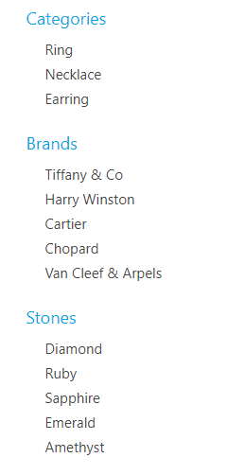

The page also have Sort by function, user can sort product(s) by Alphabet or Number

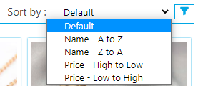

On the bottom have pagination bar. Click change to another page view more products.

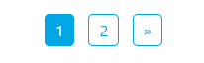

* Search page : display product(s) contain the keyword by user has input on the search bar.

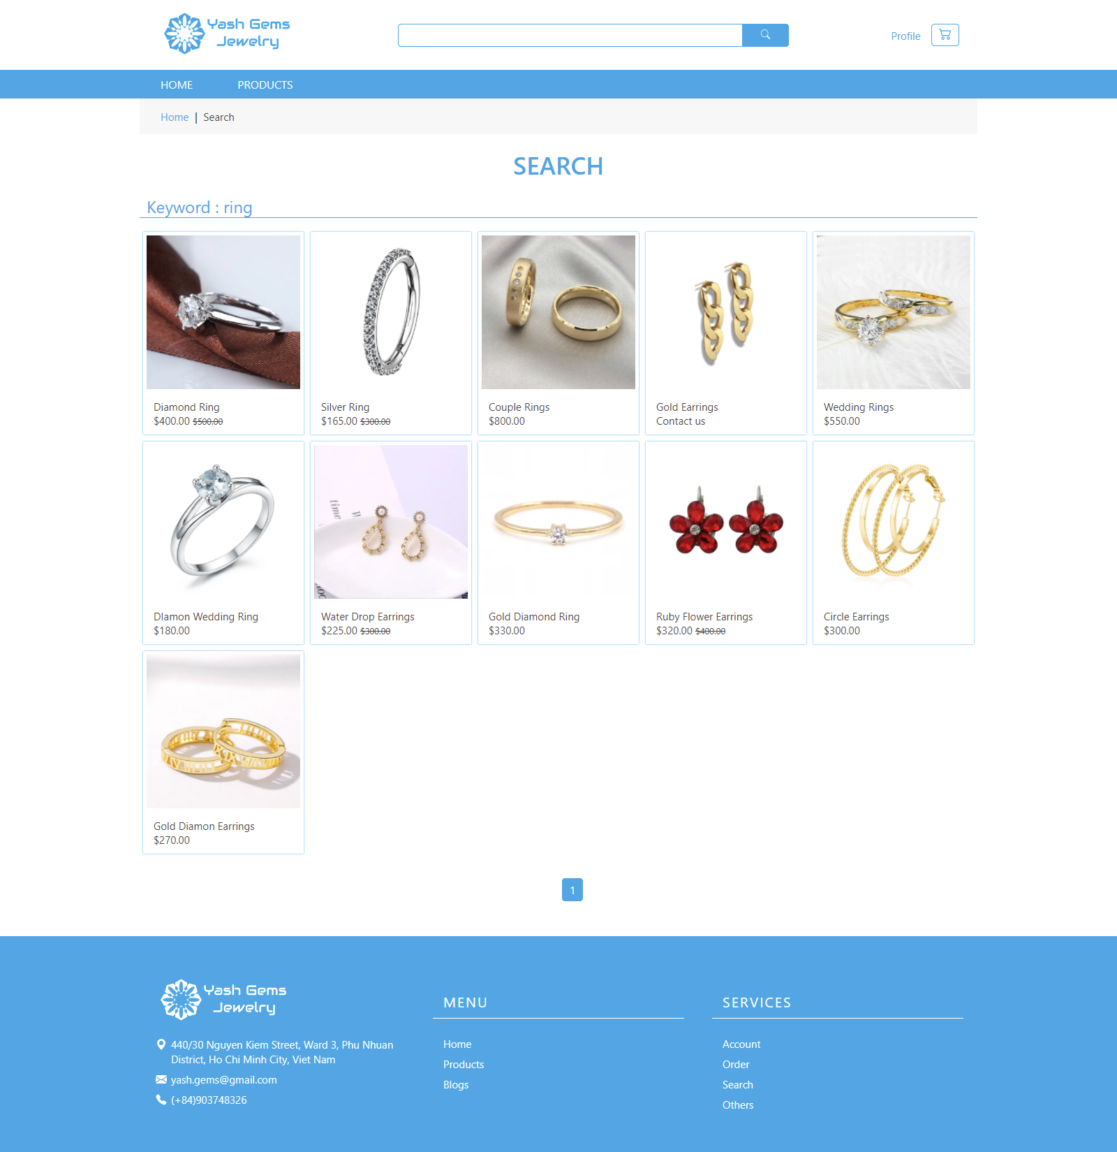

* Product Detail page : display details of product user has chosen.

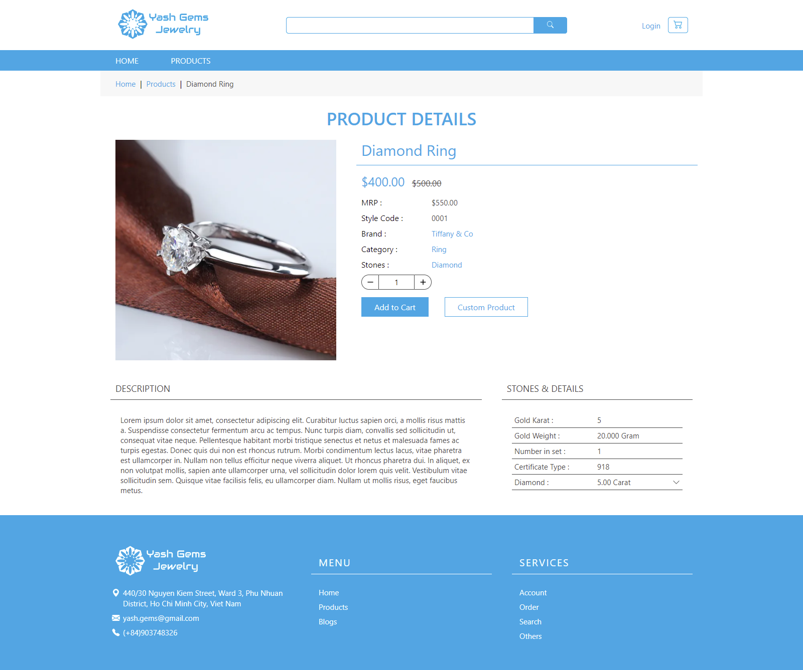

Brand, Category, Stones also can click and will show the product(s).

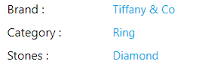

Click the button Plus or minus to change the quantity, then click Add to Cart button, add this product to shopping cart.

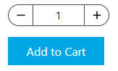

Next to the Add to Cart button, have Custom product button.

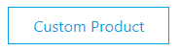

Click the button, will show the form below for user write down the inquiry of this product and send to admin.

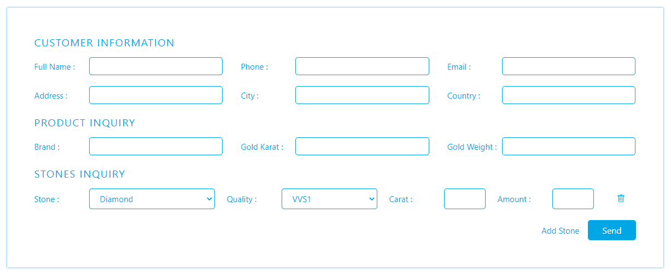

On default, Stone Inquiry just have only one row, if user want to have more than one stone, can click the Add stone to add more row.

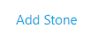

* Cart page : display the product(s) have added to the shopping cart.

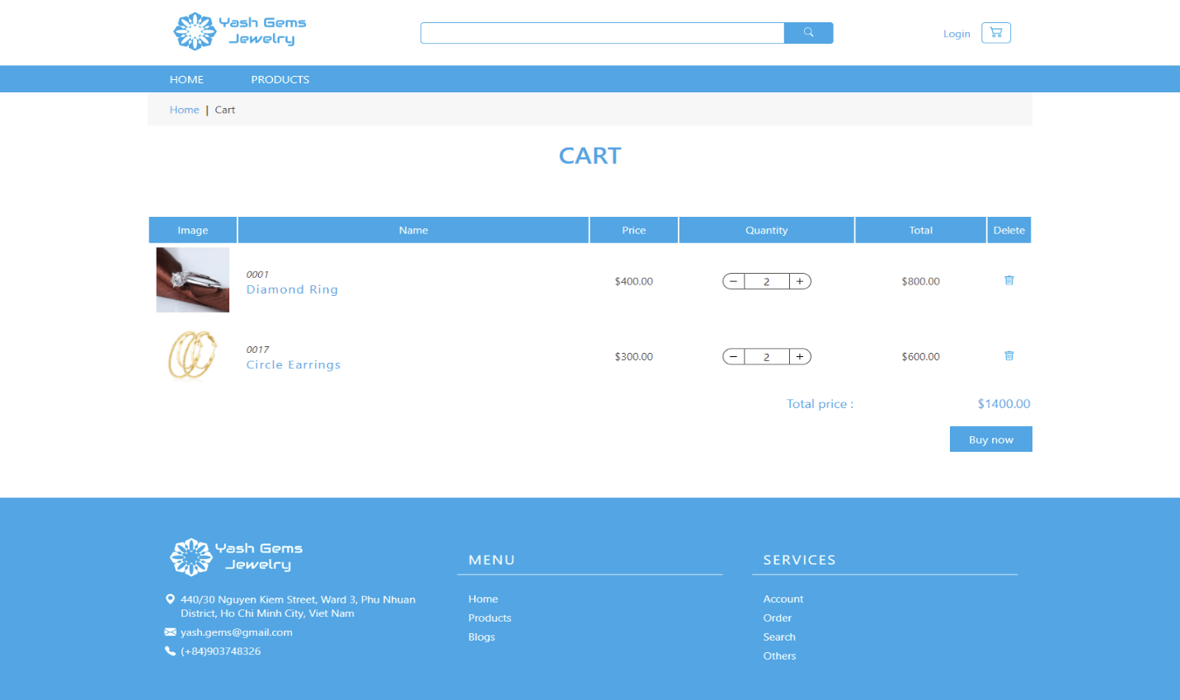

User also can change the quantity.

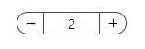

Or delete product from cart.



Click the Buy now button to go to Payment page, if user haven’t login, will go to Login page for user login.

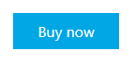

* Payment page : user fill the information then create order.

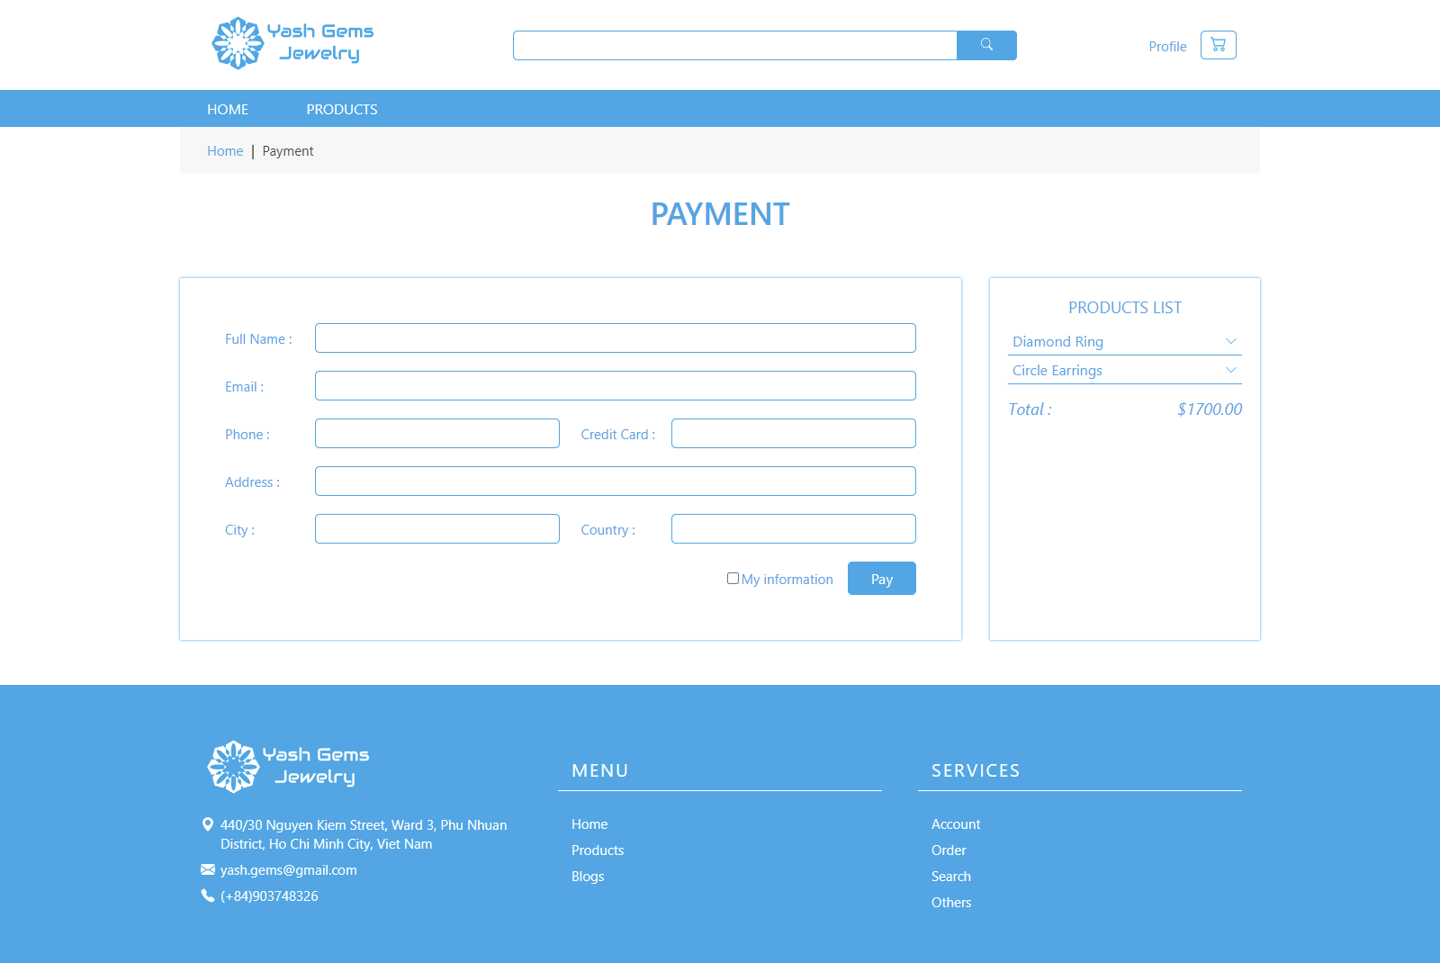

The checkbox My information, user can click and show the information to the form.

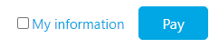

Click the Pay button create the order, your order has send to admin wait for accept.

* Login page : user login his/her account to view back the histories or create new oreder.

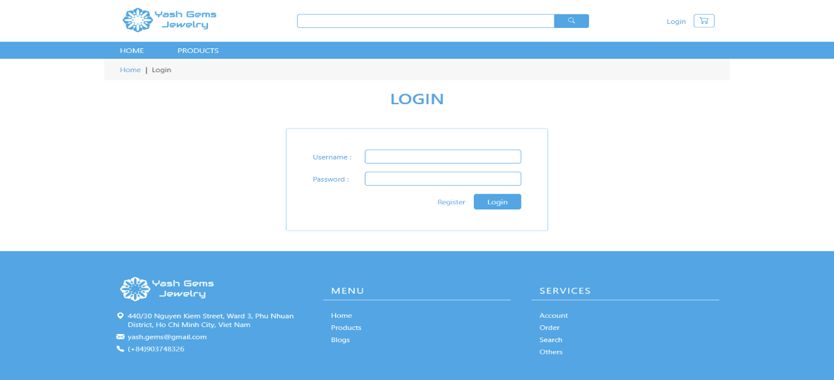

* Register page : user fill out the information form to becomes member of page.

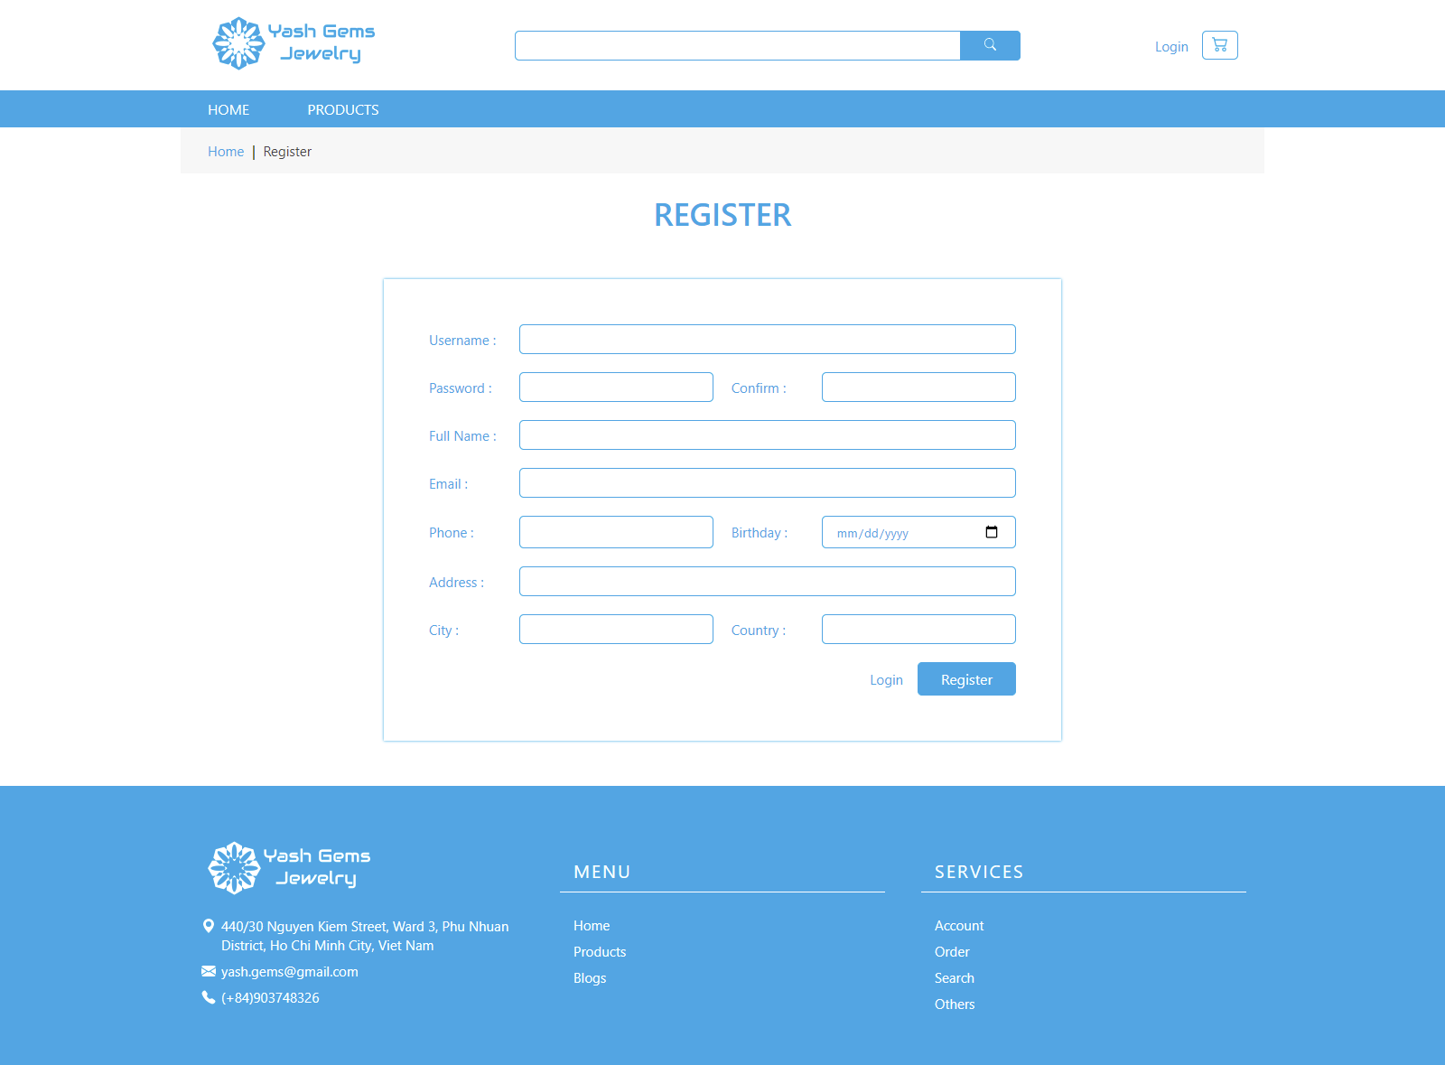

* Profile page : show the user information and histories.

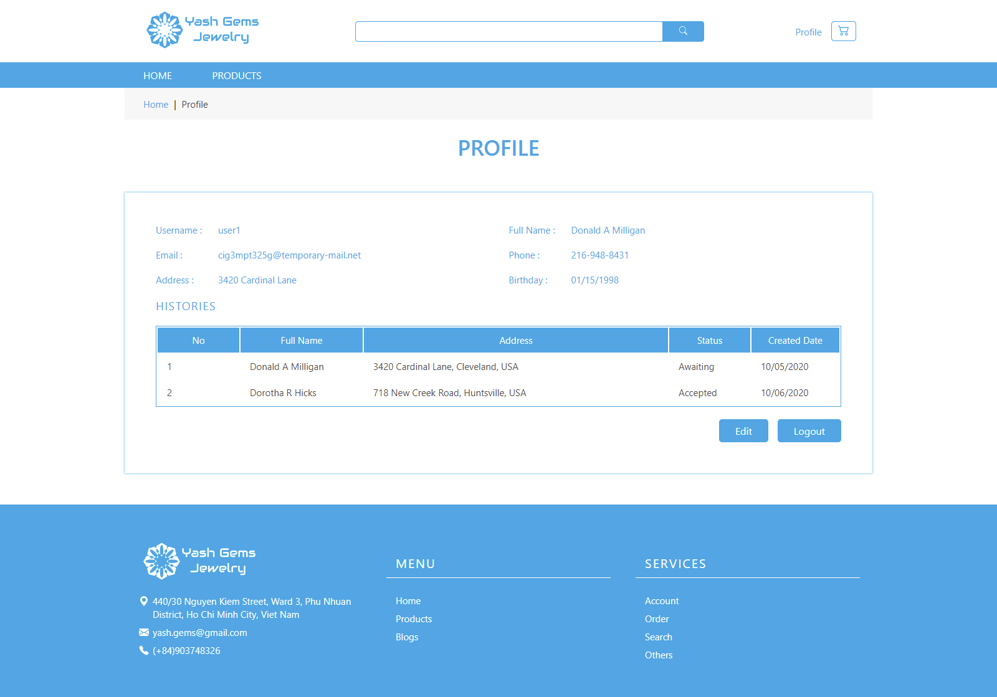

* Account edit page : allow user update their information.

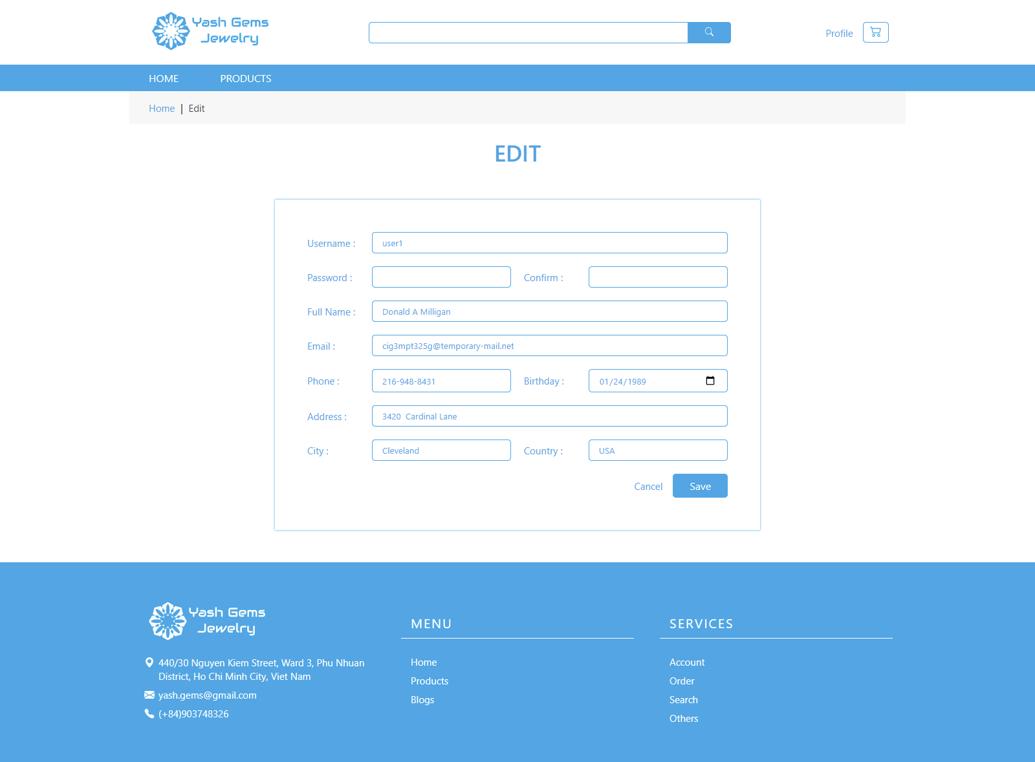

1. Admin Side :

This manual is written for users who use the website as the administrator.

**Summary:**

The admin site is created base on the necessary of management of the store manager. It requires security checking when access and user have to remember the URL to access the admin-site. There are many items handling the managements and display contents to the guest site:

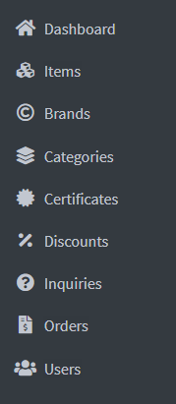Dashboard: displays the statistics of total current products, new orders, total users and unread inquiries.

Items: displays and manages items (products) sold on the website.

Brands: displays and manages the brands of products.

Categories: displays and manages the categories of products (rings, necklaces…).

Certificates: displays and manages the certificates of products.

Discounts: displays and manages discount programs.

Inquiries: displays and manages inquiries and custom orders from customers.

Orders: displays and manages the orders of customers who purchased the products on the guest-site.

Users: displays and manages customer’s accounts.

1. **Login**

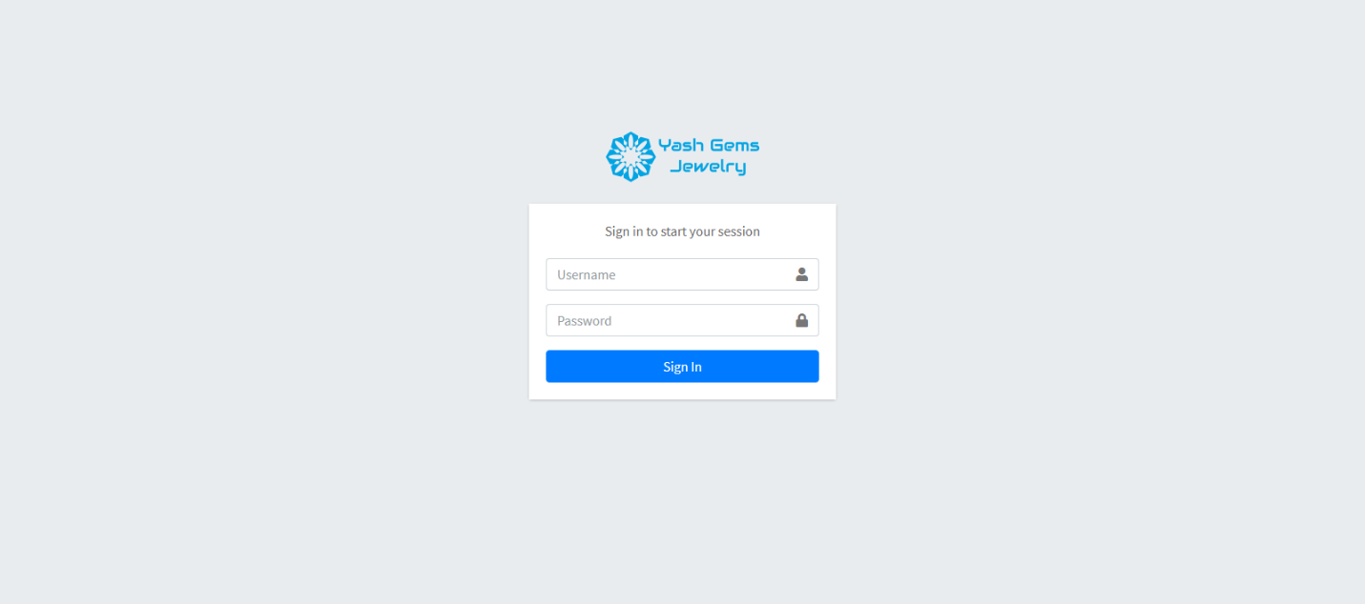

This is the login page, where the user provide the admin’s username and password to gain access. For demo purpose, the default username is “admin” and the default password is “123”. These values can be changed manually in the database (note: password is encrypted by MD5 algorithm).

Every access to the admin-sites will be linked to the login site to force users to identify their identity as admin role (if they haven’t do so already).

Admin accounts are created by the developer of the website, there won’t be a registration method.

After login success, the user - now the admin of the site, will be redirected to the dashboard site of the website. If users login failed, they continue to stay in the admin login page.

1. **Dashboard**

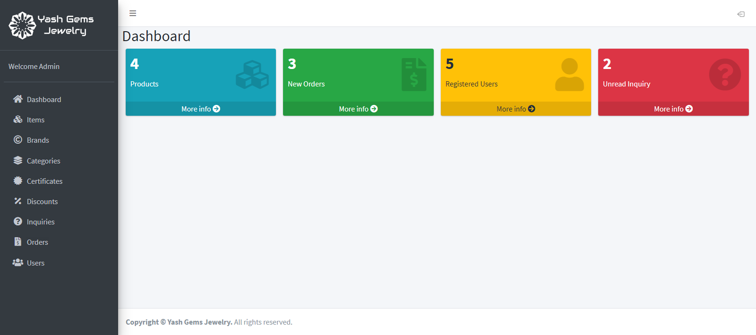

The dashboard is the first page to welcome you to the Admin area of the site. It displays the numbers of total current products (items); new orders waiting to be accepted or canceled by the admin; total registered users and the number of inquiries that haven’t been read yet.

After login successfully with role admin in admin-site, dashboard site will automatically display. To access to dashboard site by self, user click on the dashboard link on navigation bar at the left of the admin-site.

The dashboard site displays the numbers of total current products (items); new orders waiting to be accepted or canceled by the admin; total registered users and the number of inquiries that haven’t been read yet.

1. **Items**

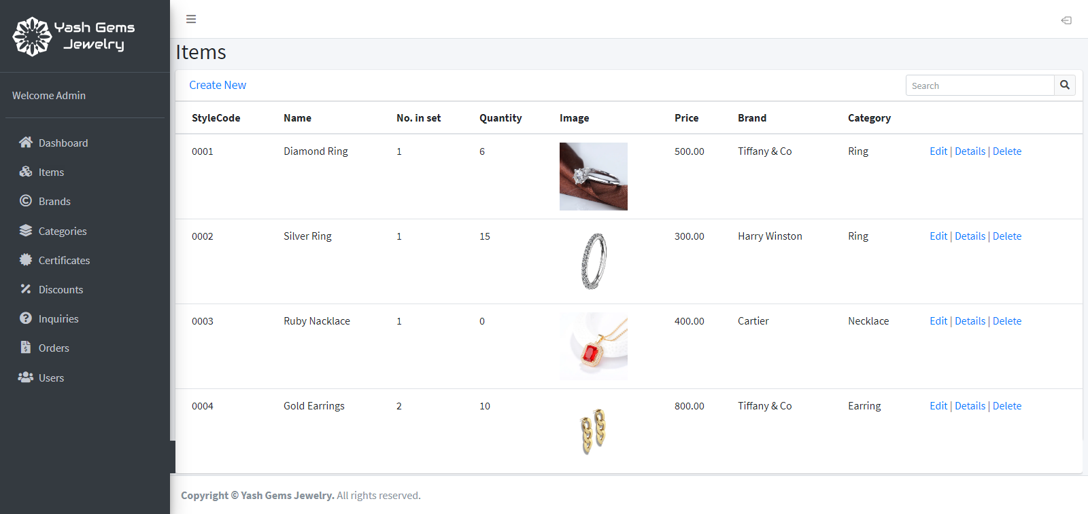

The Item page displays all items (products). The table displays general properties of items and allow user to create new items, edit current items or delete them, as well as opening Detail page containing all properties of any item. There is also a Search bar for quickly finding items with keyword.

**The Create New item page:**

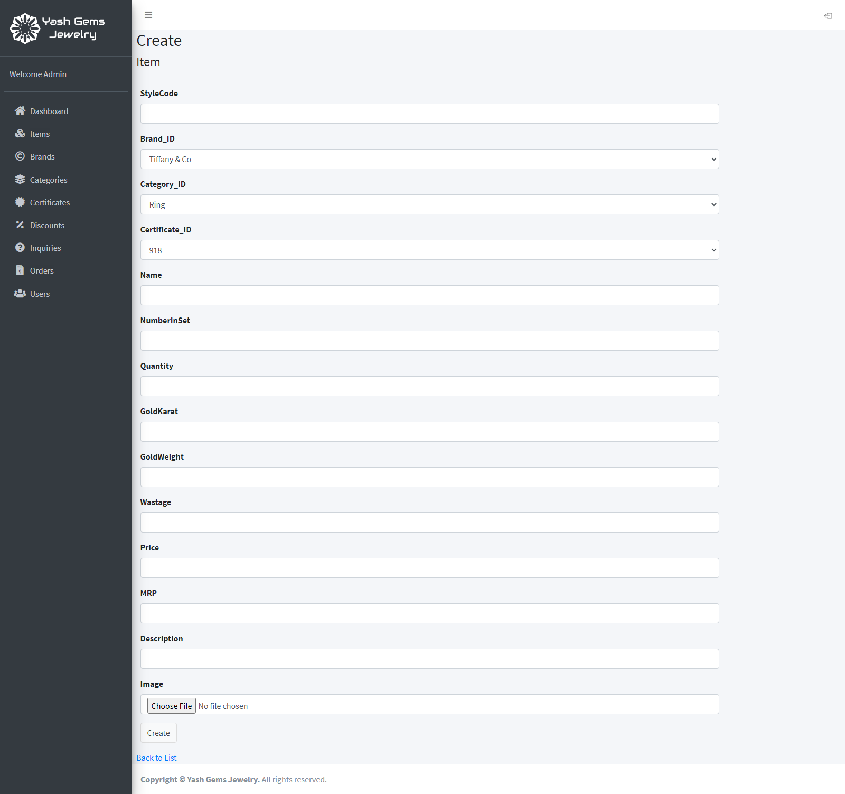

The user can fill in the form, choose values, and upload an image to be the product’s image, then click ‘Create’ to create a new item.

**The Edit page of an item:**

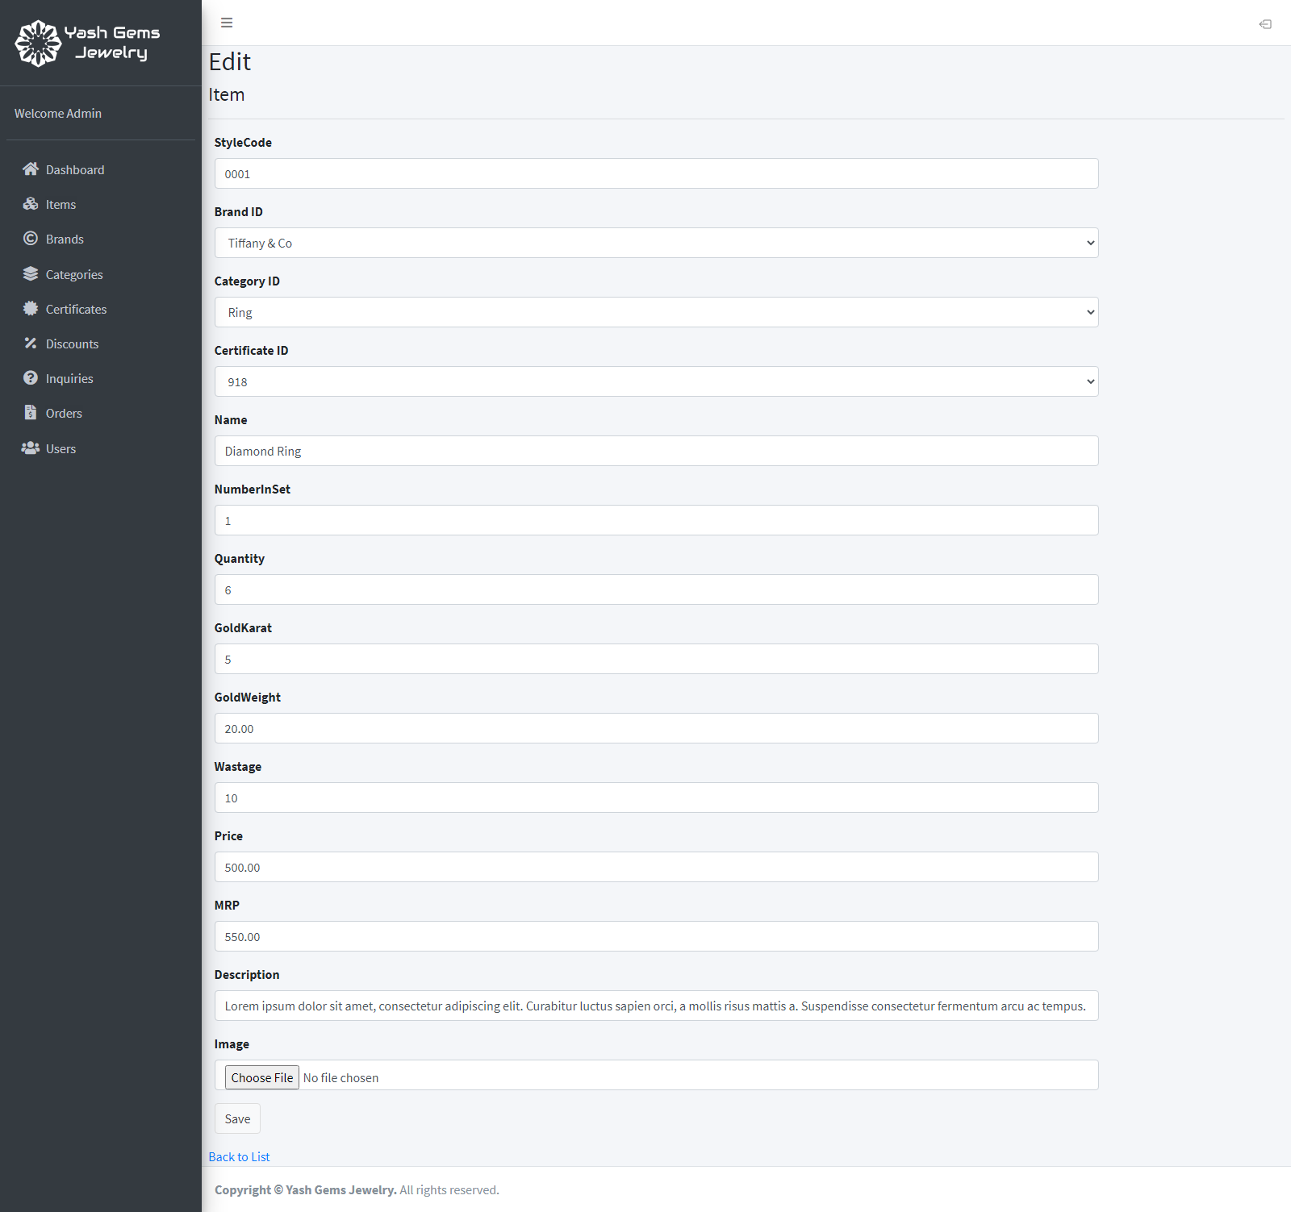

The user can change values, upload the new image to replace the old one (if no image is chosen, no change will be made to the image). Click ‘Save’ to update the item.

**The example Detail page of an item:**

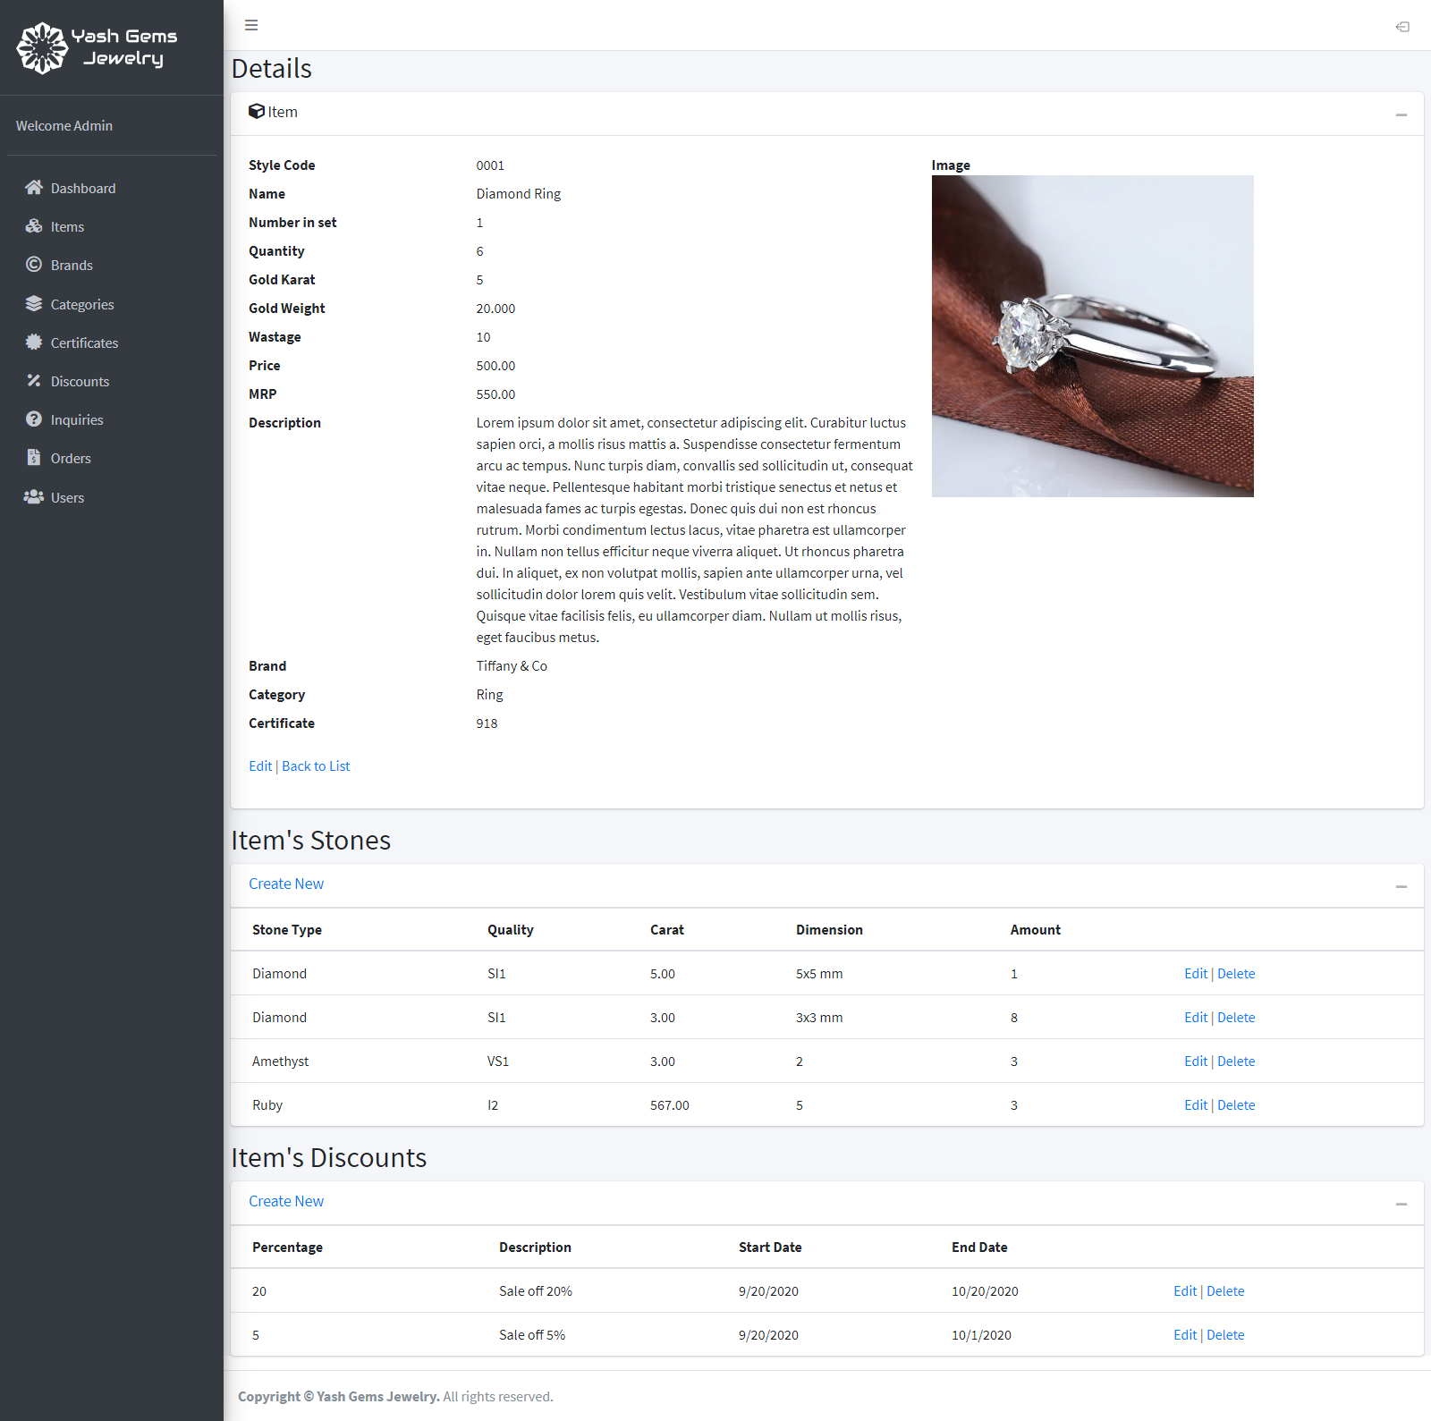

The detail page displays detailed information about the selected item (product), like the number of individual items that is in this product (like a set of earrings have 2 earrings in it), the weight and karat of the gold in the product, the product’s image…

It also display what kind of stones is in this product, like diamonds, rubies… and their quality, carat… and also allows user to add new stone to the product by clicking “Create New”, edit any stone in the product by clicking “Edit” and delete any stone by clicking “Delete”.

The discounts that is applied to this item are also displayed here, and similar to stones, you can create, edit and delete them.

1. **Brands**

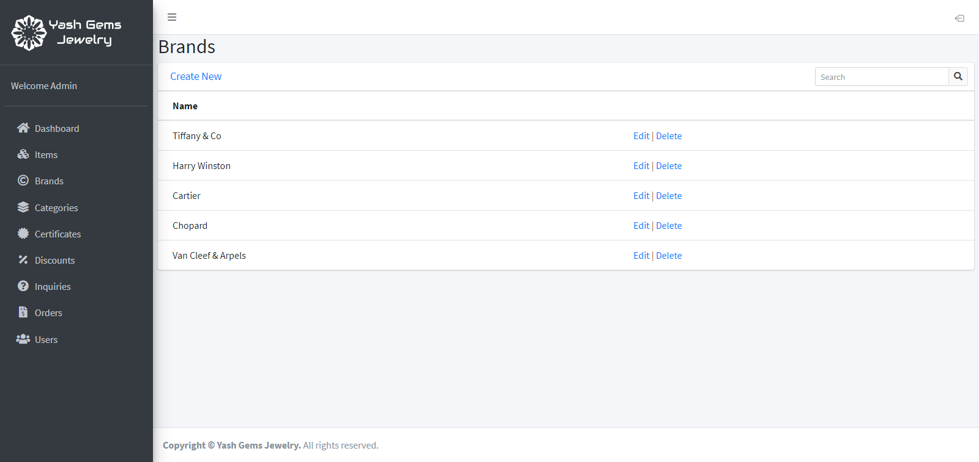

The Brands page display all brands of all current products. User can also add new brand, edit, delete, and search for brands.

1. **Categories**

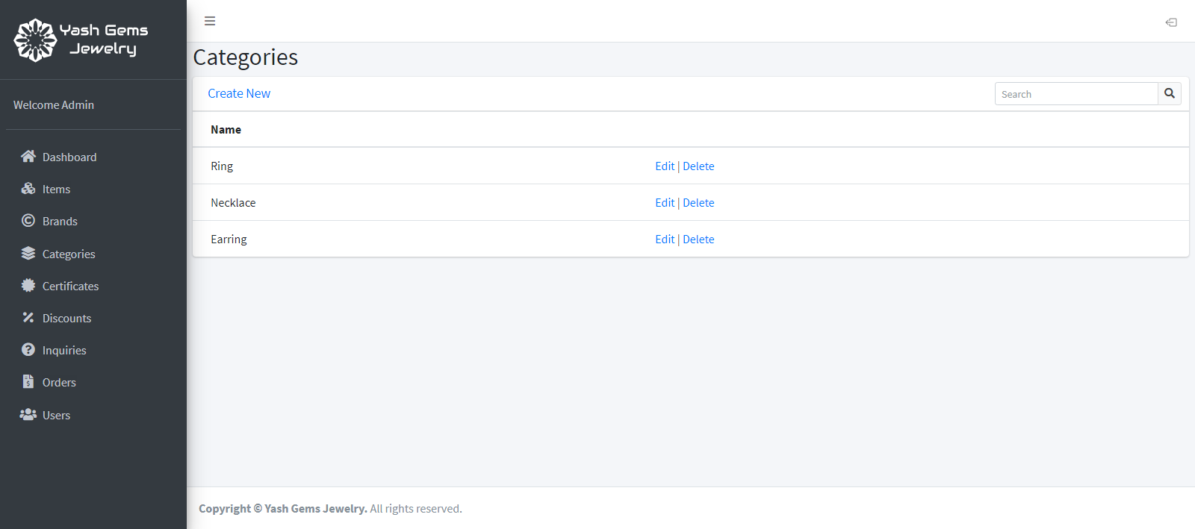

The Categories page display all categories of products. Like in Brands, user can create new, edit, delete and search.

1. **Certificates**

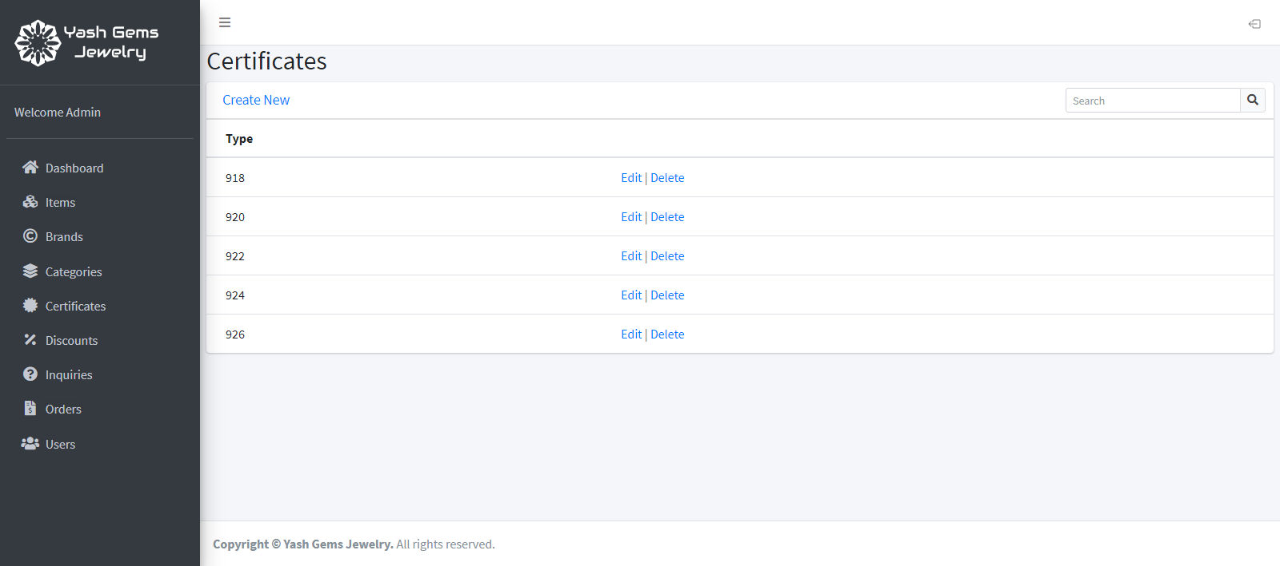

Display certificates of products, can also create new, edit, delete and search.

1. **Discounts**

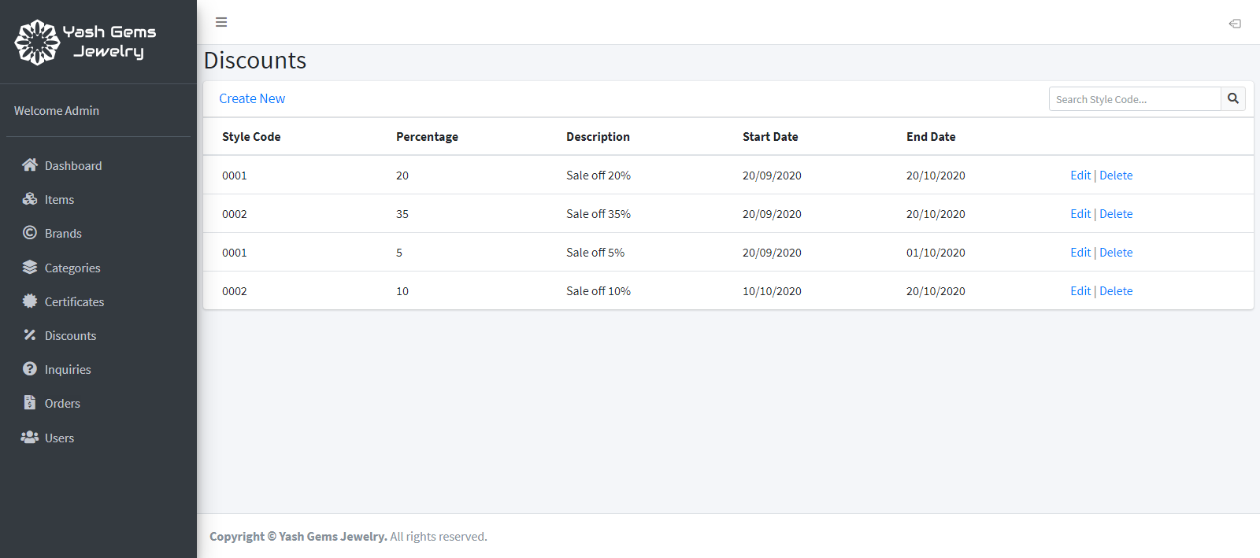

Display all discount programs applied on products. Discount programs takes effect from Start Date to End Date. The user can create new, edit and delete discount programs.

1. **Inquiries**

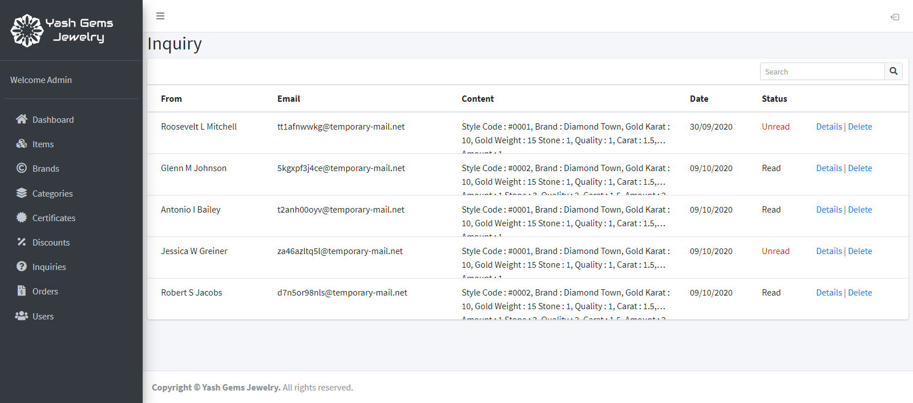

Display customers’s inquiry. While inquiries are mainly custom orders from customers and can be marked as read/unread (or deleted when not needed anymore) by the admin. Customers don’t need user account to make inquiries.

**The inquiry detail page:**

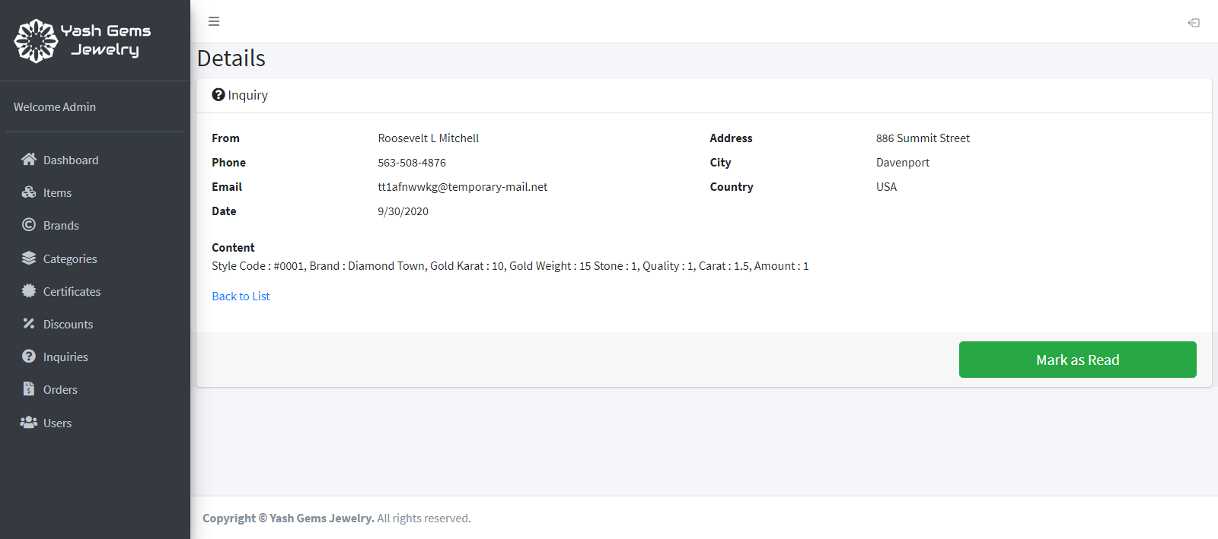

The detail page displays detailed information about the selected inqury and allows the user to mark the inquiry as “Read” with a button. After that it can also be changed back to “Unread” if the user want to.

1. **Orders**

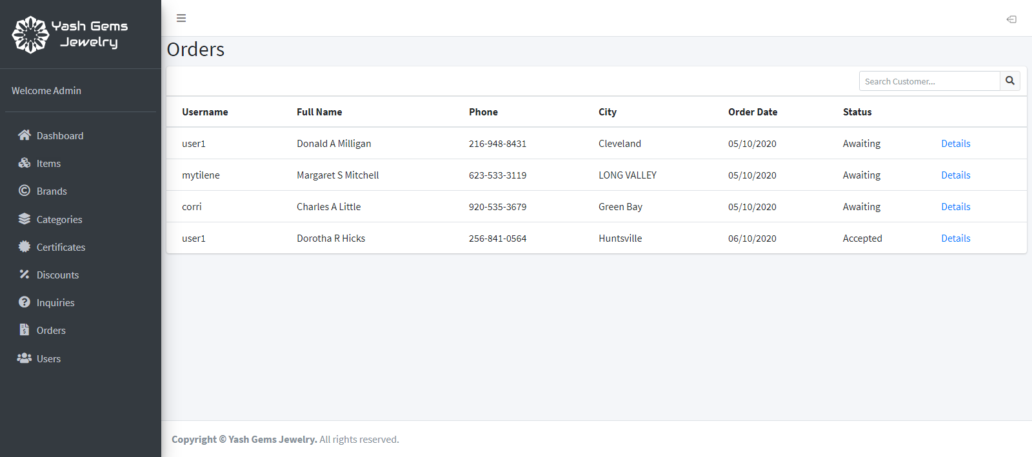

This page displays orders from customers who purchased the products on the guest-site, with the username of customer, the full name, phone number and city of the the receiver (can be the customer him/herself or a representative), the order date, and the status of the order. Status can be awaiting for acceptance by the admin, or accepted and waiting for shipment, or being shipped, or done, or canceled.

**The inquiry detail page:**

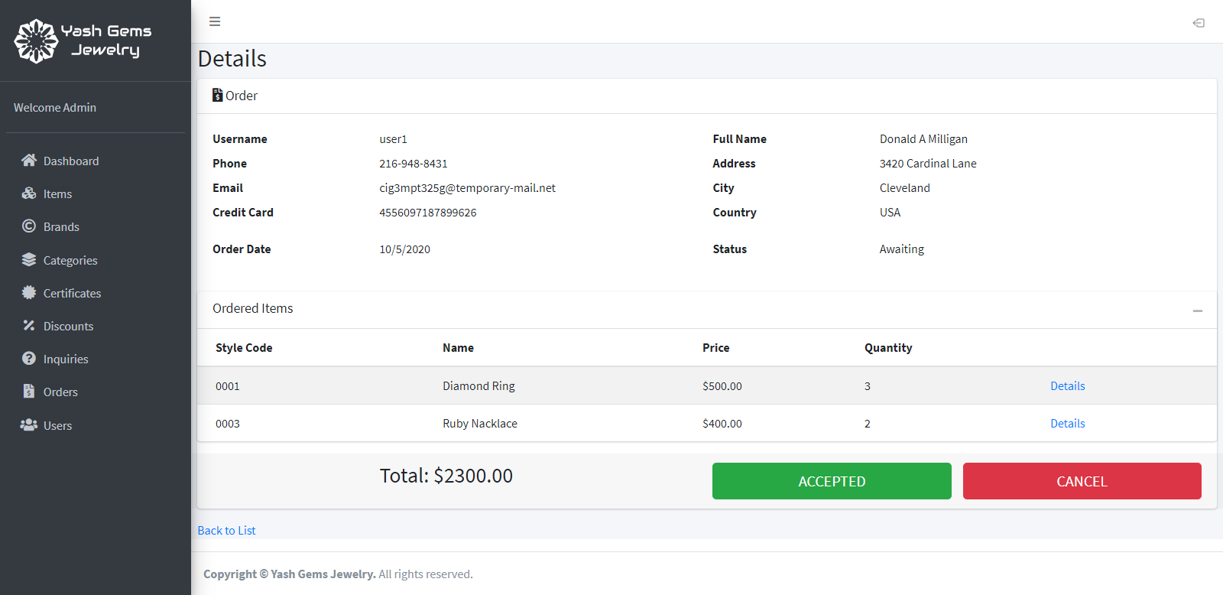

The order detail page display all information about the selected order, including the items ordered and the total price. Two buttons can make change to the status: the Accepted button would change the status from “Awaiting” to “Accepted”, after that the button will be changed to “Shipped” so when clicked will change to order’s status into the next state until it become “Done”; clicking “Cancel” anytime when the status isn’t “Done” yet will change the status to “Canceled”. When “Done” or “Canceled” the buttons will disappear so the status can’t be changed back.

1. **Users:**

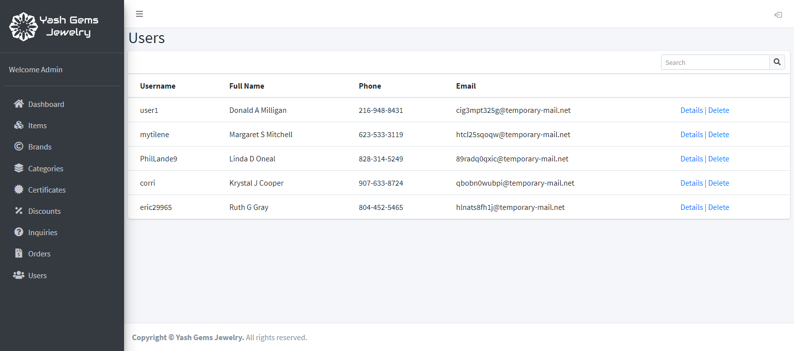

Displays customers’s accounts, click “Detail” for more information about any account.

**The user detail page:**

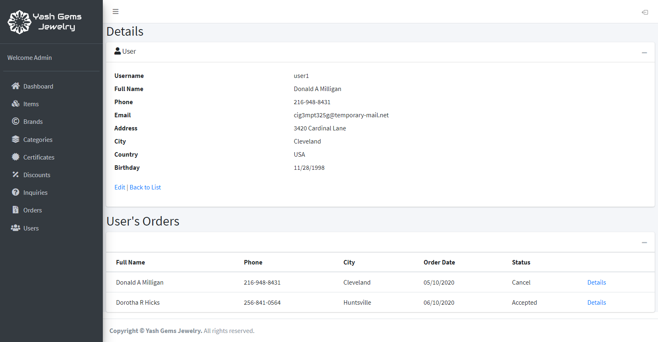

Aside from detailed information about the user’s account, any purchase order from the selected account will also be displayed, the admin can click on their detail button to view and change their status (accept, cancel…)

1. **Logout:**

The admin can logout from the admin site by clicking the Logout button located at the top-left of any admin page.

***Section 7 : Developer Guild***

1. User Side :

* Home controller : get the latest products and products on sale from database

Using function Join() to join Table ItemMst and View ItemView by Item_ID.

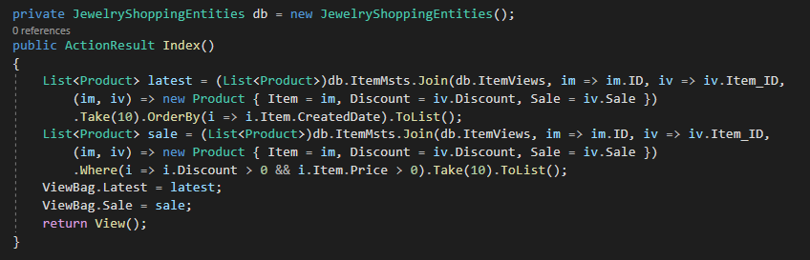

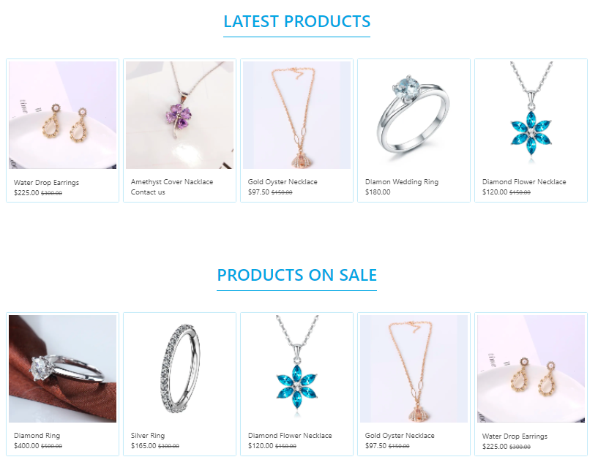

* Product controller :

the parameter id get from the View, when user choose product filter by stone, brand or category.

the parameter sort get from the View, when user choose sort by alphabet or number, user switch case to get the data then show back to page.

the parameter page is run on the first page

the parameter size is the quality of product(s) show on each page.

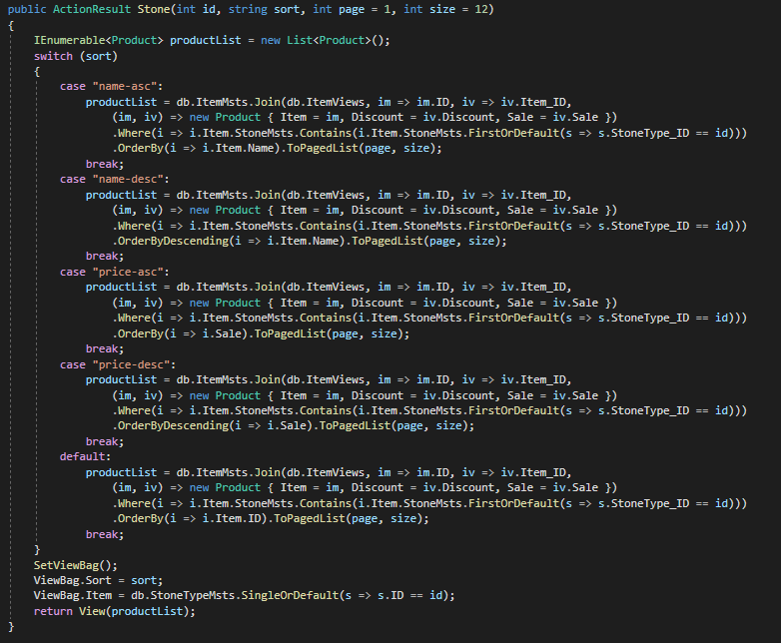

The SetViewBag function use to get the Brands, Categories and Stones.

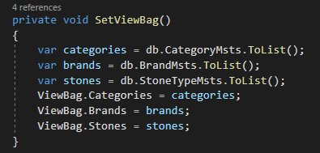

* Search Controller :

The parameter keyword get from search bar when user input the keyword.

The page and size parameters like Product Controller

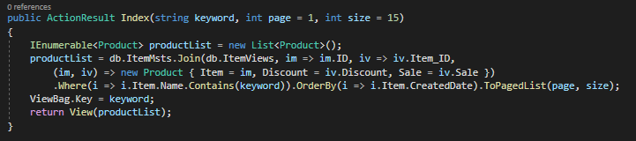

* Product Detail Controller :

The parameter id is product id, get when user click on the product.

The parameter stoneType get type of stone from StoneTypeMst

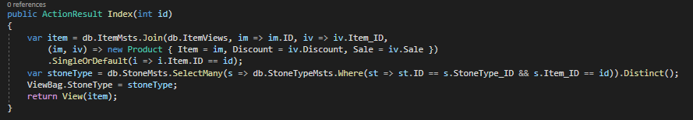

Parameters get from Inquiry from, when user send the inquiry, create InquiryMst object and add all parameter to object, then save to database.

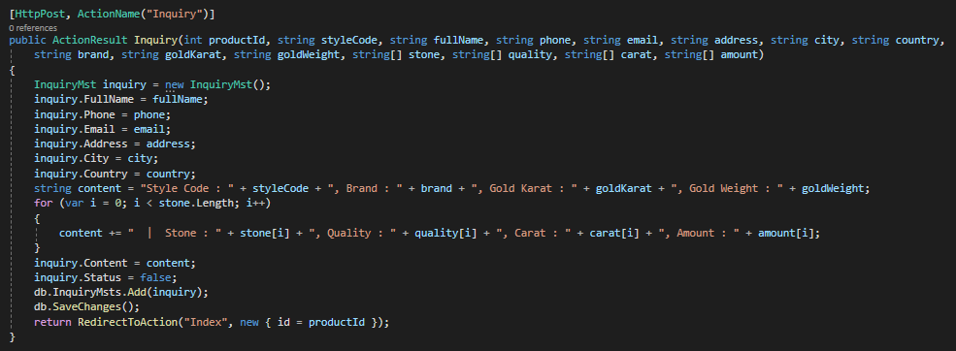

Get Stone Type and Stone Quality from database add to an object then return Json to View.

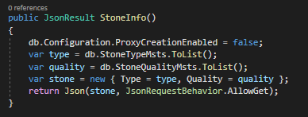

* Cart Controller :

The parameter id is get the product id.

The quantity is the quantity of product user want to buy.

Then get the Session name cart, update the quantity of product if Session create exist, if not create the Cart object then add to Session name cart.

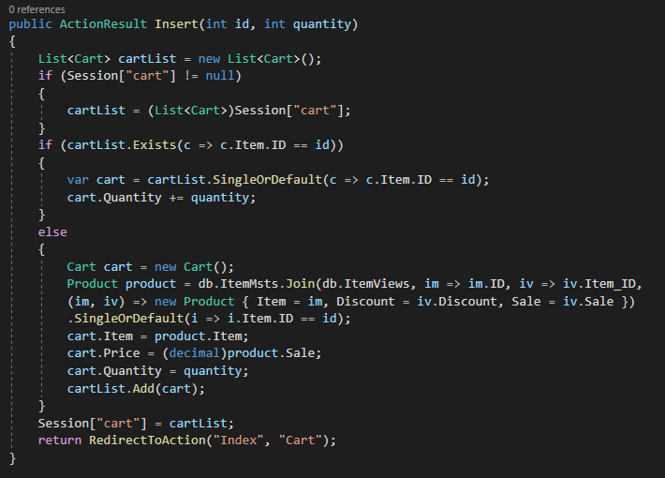

Execute the Function if quantity box in Cart index change

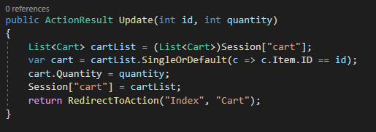

Execute this Function when user click the trash button.

Get the product id and remove from cart.

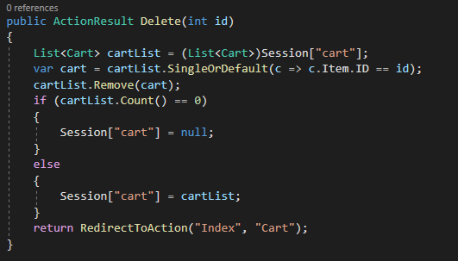

* Payment Controller :

Check Session cart and Session user. If is null back to Cart or Account index.

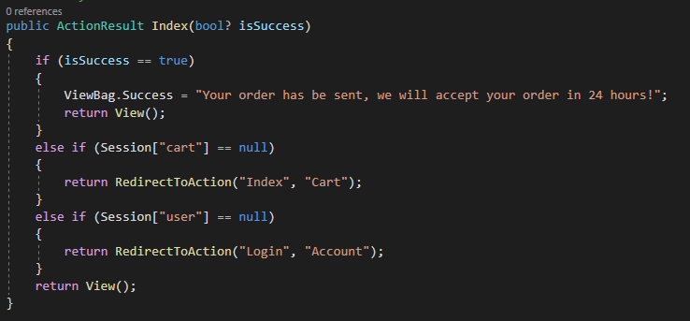

Get OrderMst object from payment form. Create and save to database.

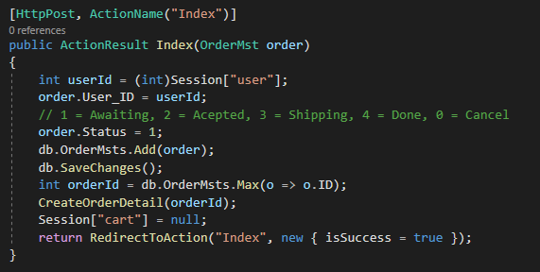

After create order, create each OrderDetailMst and add to database.

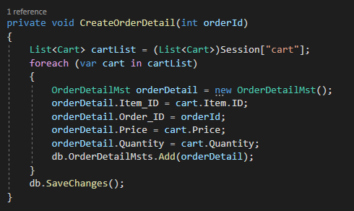

Get account information then send to View

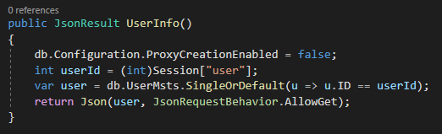

* Account Controller :

Login View

If Session user is null go to login view, if not go to profile view

After click login button check and get the user by username and password, if exist create Session user and password.

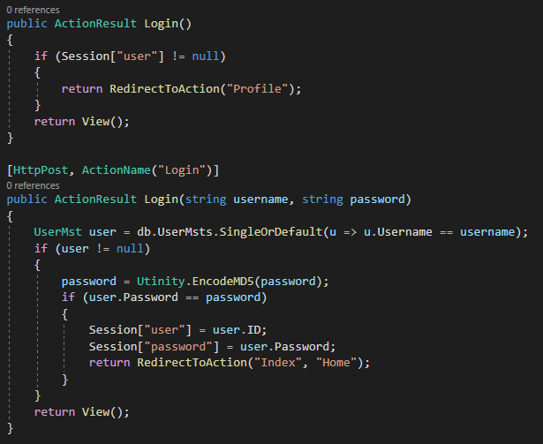

Register View:

Also like Login View, if Session user is null go to login view, if not go to profile view

Get UserMst from Register form, check username if have existed in database back to the register view, if not save this account to database.

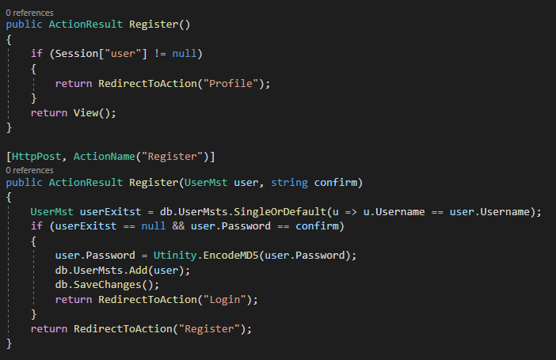

Profile View

Get UserMst and all OrderMst from database then show to view.

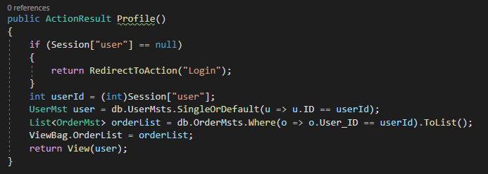

Click the Logout button on Profile view. Set Session user and password to null.

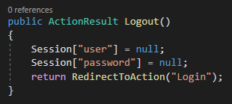

1. Admin Site

This manual is written for users who use the website as the administrator.

**Summary:**

The admin site is created base on the necessary of management of the store manager. It requires security checking when access and user have to remember the URL to access the admin-site. There are many items handling the managements and display contents to the guest site:

Dashboard: displays the statistics of total current products, new orders, total users and unread inquiries.

Items: displays and manages items (products) sold on the website.

Brands: displays and manages the brands of products.

Categories: displays and manages the categories of products (rings, necklaces…).

Certificates: displays and manages the certificates of products.

Discounts: displays and manages discount programs.

Inquiries: displays and manages inquiries and custom orders from customers.

Orders: displays and manages the orders of customers who purchased the products on the guest-site.

Users: displays and manages customer’s accounts.

1. **Login**



This is the login page, where the user provide the admin’s username and password to gain access. For demo purpose, the default username is “admin” and the default password is “123”. These values can be changed manually in the database (note: password is encrypted by MD5 algorithm).

Every access to the admin-sites will be linked to the login site to force users to identify their identity as admin role (if they haven’t do so already).

Admin accounts are created by the developer of the website, there won’t be a registration method.

After login success, the user - now the admin of the site, will be redirected to the dashboard site of the website. If users login failed, they continue to stay in the admin login page.

**Code**

Below is code for Login controller

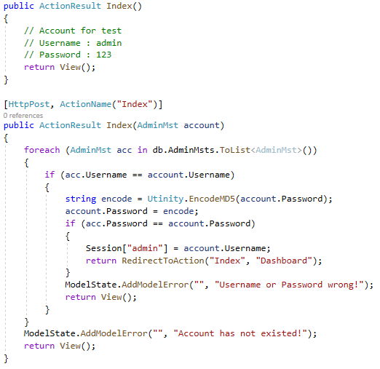

1. **Dashboard**



The dashboard is the first page to welcome you to the Admin area of the site. It displays the numbers of total current products (items); new orders waiting to be accepted or canceled by the admin; total registered users and the number of inquiries that haven’t been read yet.

After login successfully with role admin in admin-site, dashboard site will automatically display. To access to dashboard site by self, user click on the dashboard link on navigation bar at the left of the admin-site.

The dashboard site displays the numbers of total current products (items); new orders waiting to be accepted or canceled by the admin; total registered users and the number of inquiries that haven’t been read yet.

**Code**

Below is code of Dashboard controller

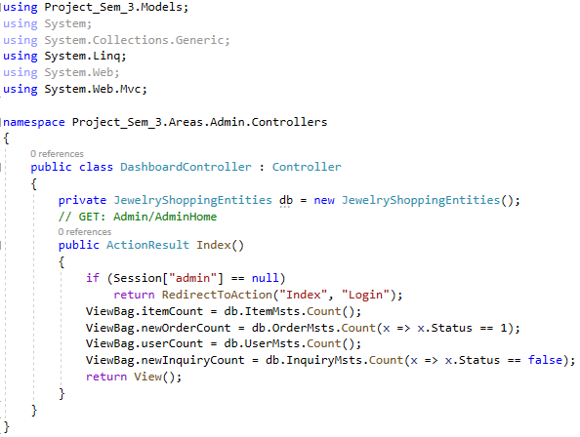

1. **Items**



The Item page displays all items (products). The table displays general properties of items and allow user to create new items, edit current items or delete them, as well as opening Detail page containing all properties of any item. There is also a Search bar for quickly finding items with keyword.

**Code**

Below is code for Item page in Item controller

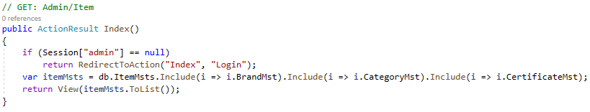

**The Create New item page:**



The user can fill in the form, choose values, and upload an image to be the product’s image, then click ‘Create’ to create a new item.

**Code**

Below is code for Create Item in Item controller

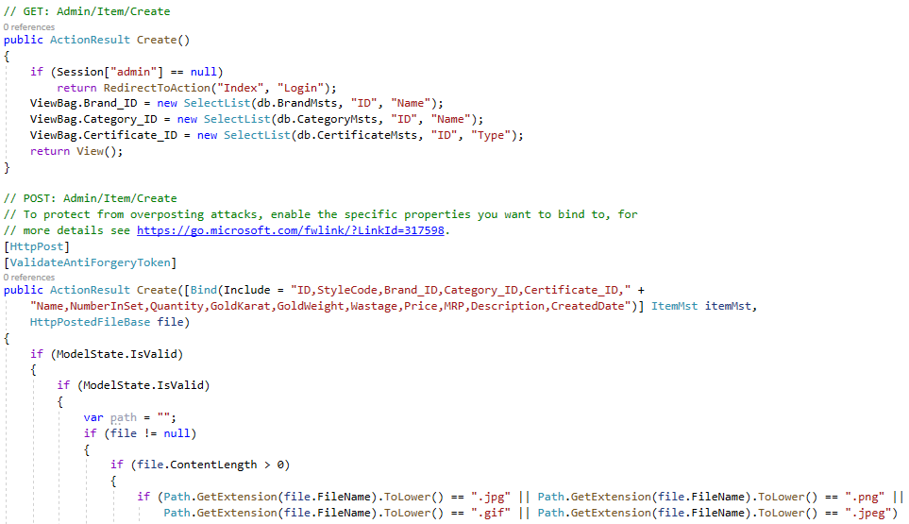

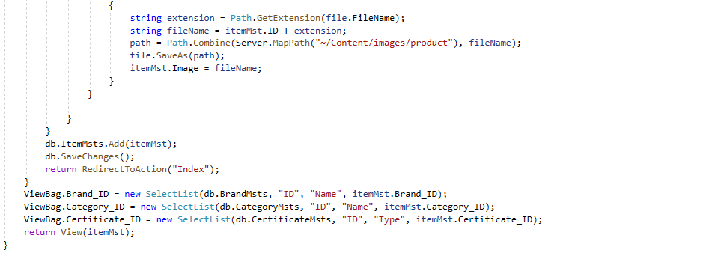

**The Edit page of an item:**



The user can change values, upload the new image to replace the old one (if no image is chosen, no change will be made to the image). Click ‘Save’ to update the item.

**Code**

Below is code for Edit Item for Item controller

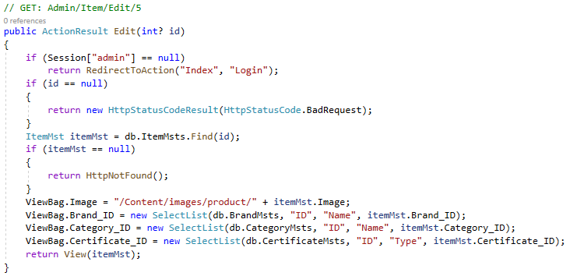

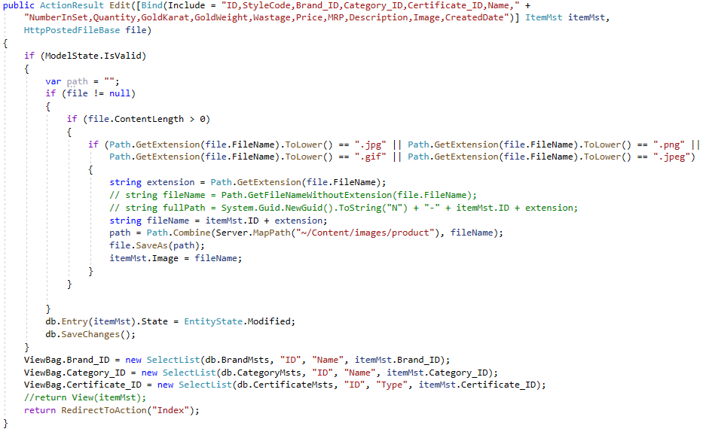

Code for Item Delete:

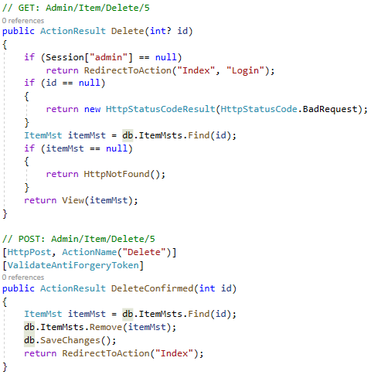

**The example Detail page of an item:**



The detail page displays detailed information about the selected item (product), like the number of individual items that is in this product (like a set of earrings have 2 earrings in it), the weight and karat of the gold in the product, the product’s image…

It also display what kind of stones is in this product, like diamonds, rubies… and their quality, carat… and also allows user to add new stone to the product by clicking “Create New”, edit any stone in the product by clicking “Edit” and delete any stone by clicking “Delete”.

The discounts that is applied to this item are also displayed here, and similar to stones, you can create, edit and delete them.

**Code**

Below is code for Item Detail in Item controller

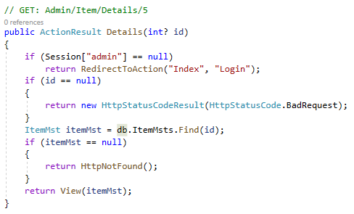

1. **Brands**



The Brands page display all brands of all current products. User can also add new brand, edit, delete, and search for brands.

**Code**

Below is code for Brands controller

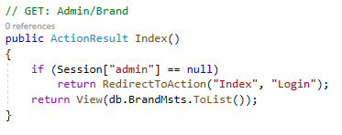

Code for Brand create, edit and delete are similar to Item.

1. **Categories**



The Categories page display all categories of products. Like in Brands, user can create new, edit, delete and search.

**Code**

Below is code for Category controller

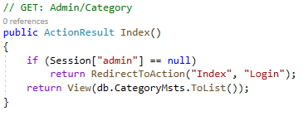

Code for Category create, edit and delete are similar to Item.

1. **Certificates**



Display certificates of products, can also create new, edit, delete and search.

**Code**

Below is code for Certificate controller

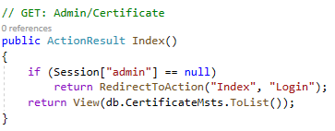

Code for Certificate create, edit and delete are similar to Item.

1. **Discounts**



Display all discount programs applied on products. Discount programs takes effect from Start Date to End Date. The user can create new, edit and delete discount programs.

**Code**

Below is code for Discount controller

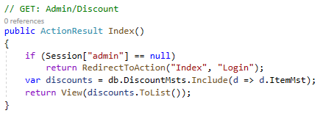

Code for Discount create, edit and delete are similar to Item.

1. **Inquiries**



Display customers’s inquiry. While inquiries are mainly custom orders from customers and can be marked as read/unread (or deleted when not needed anymore) by the admin. Customers don’t need user account to make inquiries.

**Code**

Below is code for Inquiry controller

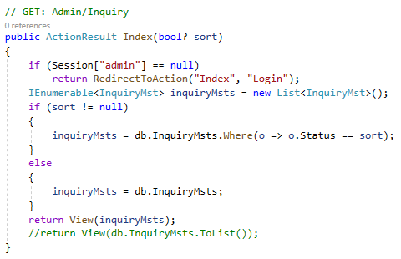

**The inquiry detail page:**



The detail page displays detailed information about the selected inqury and allows the user to mark the inquiry as “Read” with a button. After that it can also be changed back to “Unread” if the user want to.

**Code**

Below is code for Inquiry Details controller

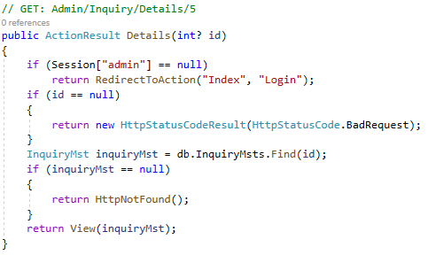

Code for Inquiry create, edit and delete are similar to Item.

1. **Orders**



This page displays orders from customers who purchased the products on the guest-site, with the username of customer, the full name, phone number and city of the the receiver (can be the customer him/herself or a representative), the order date, and the status of the order. Status can be awaiting for acceptance by the admin, or accepted and waiting for shipment, or being shipped, or done, or canceled.

**Code**

Below is code for Order controller

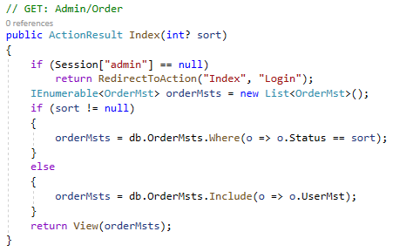

**The order detail page:**



The order detail page display all information about the selected order, including the items ordered and the total price. Two buttons can make change to the status: the Accepted button would change the status from “Awaiting” to “Accepted”, after that the button will be changed to “Shipped” so when clicked will change to order’s status into the next state until it become “Done”; clicking “Cancel” anytime when the status isn’t “Done” yet will change the status to “Canceled”. When “Done” or “Canceled” the buttons will disappear so the status can’t be changed back.

**Code**

Below is code for Order Detail controller

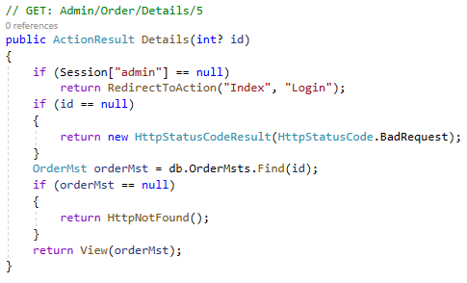

Code for Order create, edit and delete are similar to Item.

1. **Users:**



Displays customers’s accounts, click “Detail” for more information about any account.

**Code**

Below is code for User controller

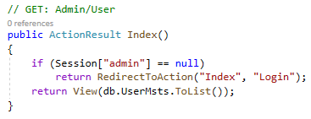

**The user detail page:**



Aside from detailed information about the user’s account, any purchase order from the selected account will also be displayed, the admin can click on their detail button to view and change their status (accept, cancel…)

**Code**

Below is code for User Detail controller

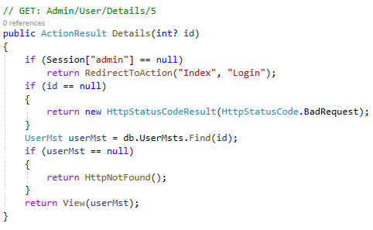

1. **Logout:**

The admin can logout from the admin site by clicking the Logout button located at the top-left of any admin page.

**Code**

Below is code for Logout in LoginController.

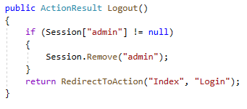

# END